
CAPSTONE PROJECT REPORT SUBMITTED TO THE
INDIAN SCHOOL OF BUSINESS
FOR THE
ADVANCED MANAGEMENT PROGRAMME IN BUSINESS ANALYTICS
DEMAND PREDICTION BY SKU: FORECASTING LUMPY ROOM AIR-CONDITIONER DEMAND FOR DEPOT REPLENISHMENT
SUBMITTED BY
Sai Prashanth Sarathy 12510081
R Arvindshankar 12510053
Hariharan N 12510102
Vedika Sharma 12510071
Vani Som 12510023
UNDER THE GUIDANCE OF
[Faculty Mentor Name], Institute of Data Science, Indian School of Business
[Industry Mentor Name], Deloitte Touche Tohmatsu India LLP
AMPBA Class of 2026S | October 2026

Certificate
Item | Details
Title of the Capstone Project | Demand Prediction by SKU: Forecasting Lumpy Room Air-Conditioner Demand for Depot Replenishment
Name(s) of the Candidate(s) | Sai Prashanth Sarathy (12510081); R Arvindshankar (12510053); Hariharan N (12510102); Vedika Sharma (12510071); Vani Som (12510023)
Name & Affiliation of the Faculty Mentor | [Faculty Mentor Name], Institute of Data Science, ISB
Name & Affiliation of the Industry Mentor | [Industry Mentor Name], Deloitte Touche Tohmatsu India LLP
Batch | AMPBA Class of 2026S
Date / Month of Submission | October 2026

Declaration of Originality
We declare that this report is our own original work, prepared for the Capstone Project of the Advanced Management Programme in Business Analytics at the Indian School of Business. All sources of information used have been duly acknowledged and cited. Our use of generative-AI tools is disclosed in Appendix A. We understand that any violation of the honor code will attract the penalties specified therein.
Name | PGID | Signature | Date
Sai Prashanth Sarathy | 12510081
R Arvindshankar | 12510053
Hariharan N | 12510102
Vedika Sharma | 12510071
Vani Som | 12510023

Sponsor Confidentiality Note
This report draws on a confidential billing extract that Deloitte's client, a room air-conditioner manufacturer, shared for this capstone. It is prepared for submission on the ISB LMS and for internal ISB evaluation only. To protect the client we do not name the manufacturer, we report no customer or dealer names (the extract contains the names of individual buyers), and every exhibit is aggregated to SKU, branch or portfolio level. Sponsor review status: [confirm whether Deloitte has reviewed and approved this version, and the date of approval].

Acknowledgements
We thank the Indian School of Business and the Institute of Data Science for the opportunity to work on a live industry problem as part of the Advanced Management Programme in Business Analytics. We are grateful to our faculty mentor, [Faculty Mentor Name], for steady guidance on methodology and for pushing us to connect forecast accuracy to inventory decisions, and to our industry mentor, [Industry Mentor Name], and the Deloitte team for framing the business problem, arranging access to the data and answering our many questions about how depots plan replenishment. We also thank the manufacturer's planning team, whose data made this work possible.

Sai Prashanth Sarathy, R Arvindshankar, Hariharan N, Vedika Sharma, Vani Som
October 2026
Table of Contents

Certificate i
Declaration of Originality i
Sponsor Confidentiality Note i
Acknowledgements iii
List of Tables vii
List of Figures viii
List of Abbreviations ix
Abstract xi
Executive Summary xii
Chapter 1: Introduction 1
1.1 Background and Context 1
1.2 Problem Statement, Objectives and Significance 1
1.3 Scope and Limitations 2
1.4 Key Terminology 2
1.4.1 Intermittent and lumpy demand 2
1.4.2 Weighted absolute percentage error (WAPE) 3
1.4.3 Rolling-origin evaluation 3
1.4.4 Safety stock and service level 3
Chapter 2: Review of Related Literature 4
2.1 Classifying Demand Patterns 4
2.2 Estimators for Intermittent Demand 4
2.3 Machine Learning and Global Models 5
2.4 Measuring Forecast Accuracy 5
2.5 From Forecasts to Inventory Decisions 6
Chapter 3: Business Context and Data 8
3.1 Business / Research Problem 8
3.2 Data Available 8
Notable features in the data 10
3.3 Data Governance and Ethics 10
Chapter 4: Methodology: Assumptions and Approach 12
4.1 Assumptions 12
4.2 Approach and Tools 13
Candidate methods 13
Rolling-origin evaluation 13
Metrics and selection 14
From forecast error to safety stock 14
Tools and technologies 15
Chapter 5: Exploratory Data Analysis 16
5.1 Data Quality and Cleaning 16
5.2 Volume over Time and Seasonality 17
5.3 Branches 19
5.4 Products and Customers 19
5.5 Order Sizes and Intermittency 20
5.6 Demand Classification 21
Chapter 6: Feature Selection and Engineering 23
6.1 Target and Training Design 23
6.2 Engineered Features 23
6.3 Features Dropped and Encoding Choices 24
6.4 Which Features Mattered 24
Chapter 7: Modelling and Results 26
7.1 Models and Metrics Considered 26
7.2 Models Chosen 27
7.3 Results 27
Overall accuracy 27
Where the advantage lies 29
Does choosing a model per series help? 31
Chapter 8: Deployment, Validation and Responsible AI 32
8.1 Deployment and Evaluation 32
8.2 Fairness, Explainability and Risk 33
8.3 Monitoring Plan 34
Chapter 9: Business Impact and Recommendations 36
9.1 Recommendations and Business Impact 36
Quantifying the inventory effect 36
Recommendations 37
9.2 Implementation Roadmap 38
Chapter 10: Limitations and Future Scope 40
10.1 Limitations 40
10.2 Future Scope 41
Chapter 11: Conclusion 42
References 43
Appendices 46
Appendix A: Use of AI Tools Statement 46
Appendix B: Additional Tables and Figures 46
Appendix C: Code and Reproducibility 48
About the Authors 50

List of Tables

Table 2.1 : Synthesis of the literature and implications for this project 6
Table 3.1 : Profile of the raw billing extract by fiscal-year block 9
Table 3.2 : Fields used in the analysis and their role 10
Table 4.1 : Material assumptions, treatment and justification 12
Table 5.1 : Data quality issues and their treatment 16
Table 5.2 : Demand classes: number of series and share of volume 22
Table 6.1 : Engineered features, rationale and leakage control 23
Table 7.1 : Models and metrics considered 26
Table 7.2 : Backtest results for all twelve methods (ranked by weekly WAPE) 27
Table 7.3 : Weekly WAPE (%) by volume tier 29
Table 8.1 : Weekly WAPE (%) by branch 33
Table 8.2 : Monitoring metrics, triggers and actions 34
Table 9.1 : Out-of-sample inventory performance of error-based safety stocks, March to June 2024 36
Table 9.2 : Implementation roadmap 38
Table A.1 : Generative-AI tools used, purpose and verification 46
Table B.1 : Data dictionary of the raw billing extract 46
Table B.2 : Weekly WAPE (%) by backtest fold (fold start date shown) 47
Table B.3 : Weekly WAPE (%) by demand class and forecast horizon 48

List of Figures

Figure 3.1 : Monthly outdoor-unit billings after cleaning 9
Figure 4.1 : Analytical pipeline from raw billing lines to replenishment policy 13
Figure 4.2 : Rolling-origin backtest design: eight expanding training windows, each followed by a four-week test window 14
Figure 5.1 : From raw ERP rows to outdoor-unit demand lines 17
Figure 5.2 : Weekly outdoor-unit demand across all branches and models 18
Figure 5.3 : Seasonal index of outdoor-unit volume by calendar month, two years compared 18
Figure 5.4 : Branch share of outdoor-unit volume and year-on-year growth 19
Figure 5.5 : Cumulative share of outdoor-unit volume by SKU (Pareto curve) 20
Figure 5.6 : Outdoor-unit volume by segment, star rating and tonnage 20
Figure 5.7 : Invoice-line size and the share of zero-demand weeks per SKU × branch series 21
Figure 5.8 : Syntetos-Boylan classification of SKU × branch demand series 21
Figure 6.1 : LightGBM feature importance: share of split gain, mean of eight folds 25
Figure 7.1 : Weekly WAPE and bias by method 28
Figure 7.2 : Weekly WAPE by demand class for three representative methods 29
Figure 7.3 : Actual versus forecast demand, all series combined, across the eight backtest folds 30
Figure 7.4 : Weekly WAPE by forecast horizon 31
Figure 9.1 : Excess cover and fill rate by forecast method, March to June 2024 37

List of Abbreviations
Abbreviation | Full Form
ADI | Average Demand Interval (average number of weeks between non-zero sales)
AMPBA | Advanced Management Programme in Business Analytics
ARIMA | Autoregressive Integrated Moving Average
CSL | Cycle Service Level
CV² | Squared Coefficient of Variation of non-zero demand sizes
EDA | Exploratory Data Analysis
ERP | Enterprise Resource Planning (system of record for billing)
FY | Fiscal Year (April to March)
IDU | Indoor Unit of a split air-conditioner
LightGBM | Light Gradient Boosting Machine
MA | Moving Average
MASE | Mean Absolute Scaled Error
ML | Machine Learning
ODU | Outdoor Unit of a split air-conditioner
PII | Personally Identifiable Information
PSI | Population Stability Index
RAC | Room Air-Conditioner
RF | Random Forest
RMSE | Root Mean Squared Error
ROP | Reorder Point
SBA | Syntetos-Boylan Approximation
SES | Simple Exponential Smoothing
SKU | Stock-Keeping Unit
SS | Safety Stock
TR | Ton of Refrigeration (cooling capacity)
TSB | Teunter-Syntetos-Babai method
WAPE | Weighted Absolute Percentage Error

Abstract
Demand for room air-conditioners (RACs) in South India is strongly seasonal and, at the level at which depots replenish, sparse and volatile. Sponsored by Deloitte for a RAC manufacturer, this project asked whether SKU-level forecasting can improve weekly depot replenishment across five branches. We audited 82,034 ERP billing lines from July 2022 to June 2024, corrected a structural change in how indoor units were recorded, and built 273 weekly SKU × branch demand series for 70 outdoor-unit models. Syntetos-Boylan classification placed 75% of series in the lumpy or intermittent classes, although erratic high-volume series carry 60% of volume. We compared twelve statistical, intermittent-demand and machine-learning methods in an eight-fold rolling-origin backtest covering December 2023 to June 2024. A single global LightGBM model was the most accurate, reducing weighted absolute percentage error (WAPE) against an eight-week moving average from 104.8% to 84.7% at the weekly SKU × branch level and from 81.9% to 62.7% over four-week planning buckets. Converted into safety stock, it matched the moving average's fill rate with 19% less excess cover. The evidence favours a global machine-learning forecaster with error-based buffers, piloted in shadow mode before planners rely on it.
Keywords: SKU-level demand forecasting; intermittent demand; room air-conditioners; gradient boosting (LightGBM); rolling-origin evaluation; safety stock

Executive Summary
The problem. Our sponsor's client sells room air-conditioners through five South Indian branches. More than half of the year's volume is billed in four months, February to May, and a further spike arrives every December. Branch planners must decide each week how many units of each model to hold, two weeks before they know what dealers will order. Order too little and peak-season sales are lost; order too much and expensive stock sits in the wrong depot when the season ends. Today these decisions rest largely on recent sales averages and judgement.
What we set out to do. We asked whether forecasting demand for each model at each branch, every week, could make replenishment more accurate and reduce the stock needed to protect service. We used two years of billing records (July 2022 to June 2024), cleaned them, and tested twelve forecasting methods by replaying the past: each method forecast four weeks ahead from eight different starting points between late November 2023 and June 2024, using only the data that would have been available at the time.
What we found.
- The data needed repair before any model could be trusted. The final quarter of the extract (April to June 2024) was recorded differently: indoor units appear as separate lines for the first time, and 4,463 exact duplicate rows (about a fifth of that quarter) cannot be checked because their invoice numbers are missing. Counting both indoor and outdoor lines, as earlier work did, would have doubled apparent demand in the busiest quarter.
- Demand is genuinely hard to predict at the level planners work. Of 273 model-branch combinations, three in four sell in fewer than three weeks out of four, and a typical combination records no sale in 64% of weeks. Sixteen of 70 models produce 80% of the volume.
- One machine-learning model, trained across all products and branches together, beat every simpler rule. Its weekly error was 19% lower than an eight-week moving average and 24% lower over four-week planning buckets. Its largest advantage came at the end of the season, when simple averages kept projecting peak-season volumes.
- Picking a different method for each product did not help. Choosing each product's best method on past months and applying it to later months produced a 99% error, worse than simply using the single global model (85%).
- Better forecasts translate into leaner, not fuller, buffers. Setting safety stock from each method's own measured error, the global model delivered the same unit fill rate as the moving average (87.8%) while carrying 19% less excess stock at the end of each replenishment cycle. No method reached the 95% service target in the volatile March to June 2024 period, a sign that buffers must be recalibrated as the season turns.
What we recommend.
- Repair the data foundation first (next 4 weeks). Recover invoice numbers for April to June 2024, agree that one outdoor unit equals one unit of demand, and remove test records from planning files.
- Adopt the global model as the weekly baseline forecast (within one quarter). Plan in four-week buckets, with a simple fallback for models that have fewer than eight weeks of sales history.
- Set safety stock from measured forecast error, recalibrated monthly. This targets buffers where uncertainty is real and releases working capital elsewhere.
- Pilot in shadow mode through the next peak season at the largest branch (Chennai) and the fastest-growing branch (Kochi) before planners rely on the model.
- Focus planner attention on the sixteen models that drive 80% of volume, and manage the long tail with simple rules.
Expected impact. At the measured error levels, the global model would hold roughly 5,336 fewer units of excess cover across the network at any time than the moving-average rule, at the same service. Under our indicative assumptions of ₹25,000 per unit and a 15% annual holding cost, that is about ₹2.0 crore a year in carrying cost, before counting fewer emergency transfers between depots. These figures should be confirmed in the pilot with the manufacturer's actual costs.

Chapter 1: Introduction
Every February, a branch planner at a South Indian air-conditioner depot faces the same bet. Within weeks, dealer orders will triple; the factory needs two weeks to deliver; and each unit of the wrong model left over in June is capital that earns nothing until the next summer. Our data show the size of that bet: in the year to June 2024, billings in the peak month (March) were seven times those of the quietest month (July), and the busiest week shipped 24,938 outdoor units against an average of 6,786.

1.1 Background and Context
India's room air-conditioner market is growing quickly as incomes rise and summers grow hotter, and cooling is expected to be one of the largest drivers of the country's future electricity demand (International Energy Agency [IEA], 2018). For manufacturers, growth comes with a planning burden. Demand is concentrated in a short pre-summer window, varies sharply across cities, and is spread across many models that differ by capacity, energy rating and inverter technology.
The manufacturer in this project sells through a network of dealers served by five branches in South India. Each branch replenishes from the factory on a short lead time and must decide, week by week, how much of each model to hold. Deloitte, advising the manufacturer, asked our team to examine whether a data-driven, SKU-level demand forecast could support these decisions. The project ran from August to October 2026 and used historical billing data from July 2022 to June 2024.

1.2 Problem Statement, Objectives and Significance
Problem statement. Branch planners currently replenish largely on recent sales and judgement, without a validated forecast at the model-and-branch level. In a market where most models sell sporadically, this leads to stock in the wrong place: shortages of fast movers at the peak and surplus of slow movers after it. The question we address is: can a SKU-level weekly forecast, evaluated honestly on unseen data, predict branch demand materially better than simple rules, and does that accuracy translate into leaner safety stocks at the same service level?
Our objectives were to:
- audit and clean the ERP billing extract into a reliable weekly demand history for each model at each branch;
- characterise the demand patterns, including seasonality, concentration and intermittency, that any method must handle;
- compare statistical, intermittent-demand and machine-learning forecasters in a leakage-free rolling-origin backtest; and
- translate forecast error into safety-stock requirements and recommend a deployable approach.
Significance. For a seasonal, capital-intensive product, forecast error is paid for twice: in lost sales when stock runs short at the peak, and in carrying and transfer costs when it does not. A method that is demonstrably better than current rules, and honest about where it is not, gives the manufacturer a basis for setting buffers and for prioritising planner effort.

1.3 Scope and Limitations
In scope: outdoor units (ODUs) of split room air-conditioners billed by five branches (BLR, COK, MAA, SBD and SBD1); weekly forecasts one to four weeks ahead; and safety-stock implications for a two-week lead time.
Out of scope: factory production planning, pricing and promotion decisions, indoor units as a separate demand stream (they are paired one-to-one with outdoor units), and products outside the room air-conditioner range.
Limitations. Billings record what was shipped to dealers, not what consumers wanted, so stock-outs and dealer stocking decisions are embedded in the history. Only 103 weeks of data were available, barely two seasonal cycles, and the last quarter was recorded in a different structure. Costs used to value inventory are indicative assumptions, not the manufacturer's figures. Chapter 10 discusses each limitation in detail.

1.4 Key Terminology

1.4.1 Intermittent and lumpy demand
Demand is intermittent when many periods record no sales, and lumpy when, in addition, the quantities that do occur vary widely. Syntetos et al. (2005) classify series using the average interval between non-zero demands (ADI) and the squared coefficient of variation of their sizes (CV²), with cut-offs of 1.32 and 0.49.

1.4.2 Weighted absolute percentage error (WAPE)
WAPE is the sum of absolute forecast errors divided by the sum of actual demand. Unlike the mean absolute percentage error, it remains defined when actual demand is zero, which matters for sparse series (Hyndman & Koehler, 2006).

1.4.3 Rolling-origin evaluation
A rolling-origin evaluation repeatedly fits a method on data up to a cut-off date and scores it on the weeks that follow, then moves the cut-off forward. It mimics how a forecast is used in practice and prevents future information from leaking into training (Tashman, 2000).

1.4.4 Safety stock and service level
Safety stock is inventory held above expected lead-time demand to absorb forecast error. The cycle service level is the probability of not running out during a replenishment cycle; the fill rate is the share of demanded units served from stock (Silver et al., 2017).

Key Takeaways
- Peak-season concentration and a two-week lead time make weekly branch replenishment a high-stakes bet on model-level demand.
- Success means a forecast that is measurably better than simple rules on unseen weeks, and safety stocks that protect service with less capital.

Chapter 2: Review of Related Literature
The question of how to forecast sparse, seasonal product demand has a long history in operations research, and recent forecasting competitions have reshaped it. We organise the literature into five streams: how demand patterns are classified, which estimators suit intermittent demand, what machine learning adds, how accuracy should be measured, and how forecasts connect to inventory decisions. For each, we state what it implies for this project.

2.1 Classifying Demand Patterns
Early inventory systems treated all items alike, smoothing past demand with exponential smoothing. Croston (1972) showed that this approach is biased for items that sell infrequently, because the forecast is updated only in a way that over-reacts to the occasional sale. The practical response was to classify items first and then choose a method. Syntetos et al. (2005) proposed a two-dimensional scheme based on the average inter-demand interval (ADI) and the squared coefficient of variation of non-zero demand sizes (CV²), deriving cut-offs of 1.32 and 0.49 from the conditions under which competing estimators perform best. The resulting four classes, smooth, erratic, intermittent and lumpy, have become a standard diagnostic. Kostenko and Hyndman (2006) later argued that the boundaries can be simplified into a single rule for choosing between Croston's method and its corrected variant, reminding practitioners that the cut-offs are heuristics rather than natural laws.
For this project, the classification serves two purposes. It tells us how much of the portfolio violates the assumptions of conventional smoothing, and it gives a lens for checking whether a method's accuracy holds across very different series. We do not, however, use the class to hard-wire the choice of model, a choice we test empirically in Chapter 7.

2.2 Estimators for Intermittent Demand
Croston (1972) proposed smoothing two quantities separately: the size of non-zero demands and the interval between them, and forecasting their ratio. Syntetos and Boylan (2005) showed that Croston's estimator is itself positively biased and proposed multiplying it by (1 − α/2), where α is the smoothing constant; this Syntetos-Boylan Approximation (SBA) was more accurate on a large sample of automotive spare-parts series. Teunter et al. (2011) noted that both methods update only when a sale occurs, so a product that stops selling keeps its old forecast indefinitely. Their TSB method updates the probability of demand in every period, allowing the forecast to decay when sales dry up, which is useful for products near the end of their life. Comparing these methods on industrial data, Babai et al. (2014) found that the best choice depended on whether obsolescence was present.
These estimators share a structural weakness for our setting: they produce a flat forecast with no seasonal shape. Room air-conditioners are both intermittent and intensely seasonal, so we test the classical estimators and also a seasonally adjusted SBA that rescales the flat level with a calendar-month index. Exponential smoothing and ARIMA models, the workhorses of statistical forecasting (Box et al., 2015; Gardner, 2006), remain natural benchmarks for the smoother, higher-volume series.

2.3 Machine Learning and Global Models
Tree-based ensembles such as random forests (Breiman, 2001) and gradient-boosted trees model non-linear interactions among many predictors without assuming a distribution for demand. LightGBM (Ke et al., 2017) made gradient boosting fast enough to train on hundreds of thousands of rows by binning features into histograms. Its practical significance for retail forecasting was demonstrated in the M5 competition, in which the task was to forecast daily unit sales for 42,840 hierarchical Walmart series, many of them intermittent; most of the top-performing entries relied on LightGBM models trained across many series at once (Makridakis et al., 2022).
A key idea behind these results is the global model: one model fitted to all series, rather than one model per series. Montero-Manso and Hyndman (2021) showed formally and empirically that global models can match or beat local models even when the series are heterogeneous, because they learn shared patterns, such as seasonality and the response to recent momentum, from far more data than any single series provides. Neural networks have also been applied to intermittent demand, with Kourentzes (2013) finding that they can improve inventory outcomes even when conventional accuracy measures do not favour them.
For our sponsor, with only 103 weeks of history per series, the global argument is decisive: a model that sees all 273 model-branch series together has thousands of examples of what happens in March, while a per-series model has at most two.

2.4 Measuring Forecast Accuracy
Choosing an error measure is not a technicality when a series contains many zeros. Hyndman and Koehler (2006) showed that percentage errors such as MAPE become infinite or undefined when actual demand is zero, and proposed the mean absolute scaled error (MASE), which divides a method's error by that of a naive forecast. Volume-weighted measures such as WAPE are also widely used in supply chains because they weight errors by commercial importance. Kolassa (2016) cautioned that for count data, point-forecast measures can reward biased forecasts; for example, the mean absolute error favours a forecast of zero for any item that sells in fewer than half of the periods, so bias should always be reported alongside accuracy.
How a measure is computed matters as much as which measure is used. Tashman (2000) recommended rolling-origin, out-of-sample evaluation over a single hold-out period, because results from one origin can be dominated by whatever happened in that window. Bergmeir and Benítez (2012) compared evaluation designs for time-series predictors and recommended schemes that respect the temporal ordering of the data. We follow both: WAPE as the primary measure, MASE and bias as secondary measures, and eight rolling origins rather than one.

2.5 From Forecasts to Inventory Decisions
A forecast creates value only through the decisions it changes. Classical inventory theory sets safety stock in proportion to the standard deviation of forecast error over the replenishment lead time, scaled by a factor that reflects the target service level (Silver et al., 2017). Syntetos et al. (2016) argued that the forecasting and inventory literatures have drifted apart, and that methods should be judged on the stock and service they deliver, not on accuracy alone. Two further results shape how billing data should be read. Lee et al. (1997) showed that order streams are more variable than end-consumer demand because of batching, promotions and rationing, the "bullwhip effect"; dealer billings are therefore an amplified signal of retail demand. Fildes et al. (2009) found that planners frequently adjust statistical forecasts, and that large adjustments tend to help while small, optimistic ones tend to harm, which argues for a forecast that planners can review rather than one that replaces them.
Finally, when forecasts are produced at several levels of a hierarchy (SKU, branch, region), they should add up. Wickramasuriya et al. (2019) proposed the minimum-trace (MinT) method for reconciling forecasts optimally across levels; we note it as an extension rather than a core part of our evaluation.
Table 2.1: Synthesis of the literature and implications for this project
Stream | Key works | What the evidence says | Implication for this project
Demand classification | Syntetos et al. (2005); Kostenko & Hyndman (2006) | ADI and CV² separate smooth, erratic, intermittent and lumpy demand; cut-offs are heuristics. | Use classes to diagnose the portfolio and to report accuracy by class, not to hard-wire model choice.
Intermittent estimators | Croston (1972); Syntetos & Boylan (2005); Teunter et al. (2011); Babai et al. (2014) | SBA corrects Croston's bias; TSB handles obsolescence; none model seasonality. | Benchmark Croston, SBA and TSB, plus a seasonally adjusted SBA.
Machine learning | Breiman (2001); Ke et al. (2017); Makridakis et al. (2022); Montero-Manso & Hyndman (2021) | Global gradient-boosted models led the M5 competition on intermittent retail data. | Train one global model across all series to share seasonal patterns.
Accuracy measurement | Hyndman & Koehler (2006); Kolassa (2016); Tashman (2000); Bergmeir & Benítez (2012) | Avoid MAPE with zeros; report bias; evaluate over rolling origins. | WAPE primary, MASE and bias secondary; eight rolling origins.
Forecast to inventory | Silver et al. (2017); Syntetos et al. (2016); Lee et al. (1997); Fildes et al. (2009) | Judge forecasts by stock and service; order data amplify demand; planners adjust forecasts. | Convert errors into safety stock; treat billings as a noisy proxy; design for planner review.
Source: Team synthesis of the cited literature.
The gap this project addresses. The literature establishes how to classify intermittent demand, which estimators suit it, and that global machine-learning models can excel on large retail datasets. Far less evidence exists for durable goods that are simultaneously intermittent, intensely seasonal and short in history, and billed through dealers rather than sold at a till. Our contribution is an honest, decision-oriented comparison in exactly that setting, tied through to the safety stock a planner would hold.

Key Takeaways
- Intermittent-demand estimators fix the bias of naive smoothing but ignore seasonality; global gradient-boosted models learn shared seasonal patterns across many short series.
- Accuracy must be measured with zero-safe, volume-weighted metrics over rolling origins, and judged ultimately by its effect on stock and service.
- Evidence for seasonal, intermittent durable goods with short histories is thin; this project fills that gap for one manufacturer's network.

Chapter 3: Business Context and Data
Before choosing a method, we needed to understand the decision the forecast must support and the data it must be built from. In short, the decision is weekly, local and capital-intensive, and the data are richer than they first appear but less consistent.

3.1 Business / Research Problem
Who is affected. Five branch offices, identified in the data as MAA (Chennai), SBD, SBD1, COK (Kochi) and BLR (Bengaluru), sell to 510 registered dealers and around 2,352 billed customers. Branch planners place replenishment requests on the factory, central supply planners allocate scarce peak-season output across branches, and finance carries the cost of stock that does not sell. The project configuration maps SBD and SBD1 to the Secunderabad and Vijayawada sales offices; we refer to all branches by code.
The decision the forecast informs. Every week, for each model at each branch, a planner decides how many units to request so that stock on hand plus stock in transit covers demand until the next delivery. With a lead time of about two weeks, the forecast that matters most is demand over the next two to four weeks, and the quantity that matters most is the buffer held against error in that forecast.
What success looks like. In discussions with the sponsor, success was framed in three ways: a forecast that is demonstrably more accurate than the simple rules planners use today, evaluated on weeks the model has not seen; a buffer policy that protects service during the peak without inflating stock afterwards; and a tool planners can use and question. Because the extract does not contain planners' own historical forecasts, we use simple rules (last week's sales, and moving and smoothed averages of recent weeks) as transparent proxies for current practice.

3.2 Data Available
The sponsor provided a single extract from the manufacturer's ERP billing system: 82,034 invoice lines and 24 fields, covering billing dates from 16 July 2022 to 30 June 2024. Each line records one material billed to one customer on one date by one branch, with its quantity, capacity (tonnage), energy rating and segment. The extract spans 103 complete weeks, just over two summer peaks. Access was granted for the capstone only, under the sponsor's confidentiality terms. Table 3.1 profiles the extract by fiscal-year block, and it reveals the single most important fact about the data.
Table 3.1: Profile of the raw billing extract by fiscal-year block
Fiscal block | Billing dates | Rows | ODU lines | IDU lines | Rows without invoice no. | Exact duplicates
FY 2022-23 (part) | 16 Jul 2022 - 31 Mar 2023 | 17,879 | 17,879 | 0 | 0 | 0
FY 2023-24 | 1 Apr 2023 - 31 Mar 2024 | 40,551 | 40,551 | 0 | 0 | 0
FY 2024-25 Q1 | 3 Apr 2024 - 30 Jun 2024 | 23,603 | 11,799 | 11,804 | 23,603 | 4,463
Total | 16 Jul 2022 - 30 Jun 2024 | 82,033 | 70,229 | 11,804 | 23,603 | 4,463
Source: Sponsor ERP billing extract, July 2022 - June 2024; team analysis. One fully blank row is excluded from the counts.
Until March 2024, the extract contains only outdoor-unit (ODU) lines; the indoor-unit quantity field is zero on every row. From April 2024, every outdoor unit is accompanied by a separate indoor-unit (IDU) line for the matching indoor model; the invoice number, line item, storage location and dealer fields are blank; and 4,463 rows (5.44% of the extract, all in this quarter) are exact copies of another row. The final quarter, 28.77% of all rows, is therefore a structurally different extract appended to the first two years. Figure 3.1 shows that the volume pattern is nonetheless continuous once the indoor lines are set aside and the duplicates removed.
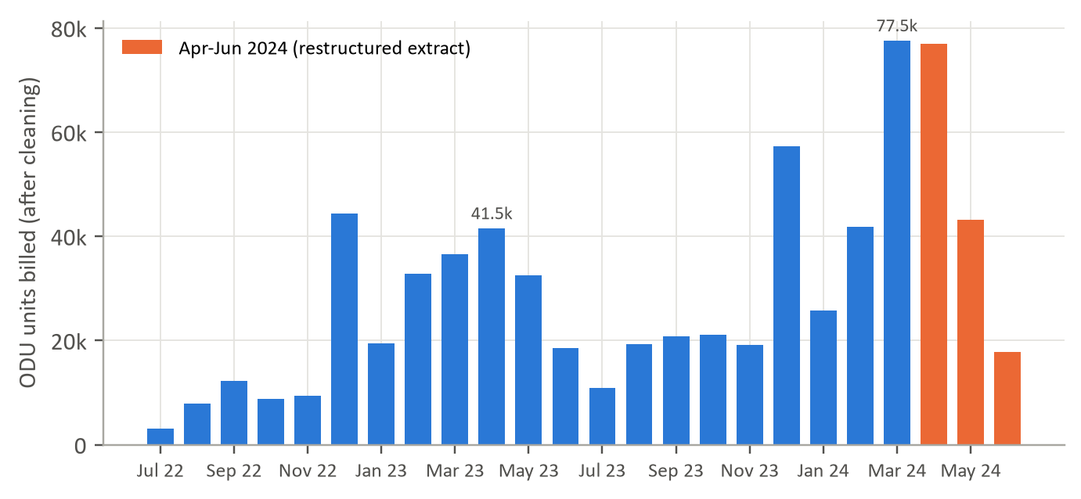
Figure 3.1: Monthly outdoor-unit billings after cleaning
Source: Sponsor ERP billing extract, July 2022 - June 2024; team analysis.

Notable features in the data
The extract describes 154 material codes, but these are two different things: 70 outdoor-unit models and 84 indoor-unit models. A split air-conditioner is sold as one outdoor and one indoor unit, so the outdoor unit is the natural unit of demand, and we model the 70 outdoor models that recorded positive sales. Table 3.2 lists the fields we used and how; the full data dictionary appears in Appendix B (Table B.1).
Table 3.2: Fields used in the analysis and their role
Field | Content | Role in the analysis
Material | Product code; 70 ODU and 84 IDU codes | SKU key (ODU codes only)
SALES OFFICE CODE | Branch: BLR, COK, MAA, SBD, SBD1 | Branch key
Billing Date | Invoice date | Aggregated to weeks ending Sunday
Billing Quantity ODU | Units billed; negative for returns | Demand target (positive lines)
EXT MAT GROUP | RA-ODU or RA-IDU | Separates outdoor and indoor lines
Segment, Star Rating, Tonnage | Inverter / non-inverter; energy rating; capacity | Product attributes and model features
Billing Doc., Item | Invoice number and line | Duplicate diagnosis (blank in Apr-Jun 2024)
Customer, Dealer Name | Buyer and channel partner | Concentration statistics only; excluded from models and outputs
Source: Sponsor ERP billing extract, July 2022 - June 2024; team analysis.
Three further features shaped our choices. First, 1,436 outdoor lines carry negative quantities, which are returns or credit notes rather than demand. Second, three fields (Material.1, SALES OFFICE CODE.1 and Tonnage.1) are exact copies of others, and one unlabelled column is almost entirely empty; together with the blank fields of the final quarter, these explain why the extract is only 91.04% complete overall but 94.99% complete once the empty column is excluded. Third, minor inconsistencies such as "3 star" alongside "3 Star" (41 rows) indicate manual entry in places, which we standardised.

3.3 Data Governance and Ethics
Personal data. The customer field contains the names of individual buyers as well as companies. We treated the field as personally identifiable information: it was used only to compute anonymous concentration statistics, was excluded from every model, and appears in no table, figure or output file. All exhibits in this report are aggregated to SKU, branch or portfolio level, and the manufacturer is not named.
Approvals and handling. The extract was shared through Deloitte for the capstone and handled only by team members. The code repository described in Appendix C contains the analysis scripts; the raw data file must not be published with it. [Team to confirm: the date of the sponsor's data-handling approval and that the repository is private or excludes the data files.]
Known biases. Billing data record shipments to dealers, not consumer purchases. When a branch ran out of a model, the lost demand is invisible, so history understates true peak demand for the models most likely to stock out. Dealer ordering also amplifies consumer demand (Lee et al., 1997): the December spike visible in Figure 3.1, outside any weather-driven season, is most plausibly year-end channel stocking. Finally, the change in extract structure in April 2024 means that the most recent, and most relevant, quarter is also the least verifiable.
Synthetic test records. During our final audit we found that a working copy of the data used by the project dashboard ("Filtered.xlsx") contains a second sheet of 5,100 synthetic rows for ten artificial evaluation SKUs, generated with a fixed random seed to test the dashboard. These rows were never part of the sponsor's data, and we excluded them from all analysis in this report. Any planning use of the dashboard must exclude them too.

Key Takeaways
- The forecast informs one weekly decision: how much of each model each branch should request against a two-week lead time, and how large a buffer to hold.
- The outdoor unit is the true unit of demand; the April to June 2024 quarter is structurally different and must be repaired before it is fully trusted.

Chapter 4: Methodology: Assumptions and Approach
Our methodology rests on a small number of explicit assumptions and a single principle: every method is judged in exactly the way it would be used, forecasting weeks it has not seen from information available at the time. This chapter states the assumptions, explains why each is reasonable, and then sets out the analytical approach and tools.

4.1 Assumptions
Table 4.1: Material assumptions, treatment and justification
Area | Assumption / treatment | Justification
Demand definition | Positive ODU billing quantity per SKU, branch and week is the demand to forecast. | Each split system ships one ODU and one IDU; IDU lines exist only from April 2024, so adding them would double-count the latest quarter.
Billings as demand | Shipments to dealers are treated as demand. | The only signal available; its censoring and amplification biases are acknowledged (Sections 3.3 and 10.1).
Duplicates | The 4,463 exact duplicate rows in Apr-Jun 2024 are removed. | No earlier period contains a single exact duplicate; identical lines with blank invoice numbers are more plausibly extraction artefacts. A sensitivity figure is reported in Section 5.1.
Returns | Negative quantities are excluded from demand and reported separately. | Returns are 0.83% of units and relate to past sales, not future demand.
Time grain | Weekly buckets ending Sunday; weeks with no sales are recorded as zero. | Matches the weekly replenishment cycle; daily data are too sparse and monthly data too coarse for a two-week lead time.
Series start | A series begins at its first sale; earlier weeks are not counted as zero demand. | Models launched mid-period were not available before launch, so earlier zeros are not true zero demand.
Independence of errors | Weekly forecast errors are treated as independent when scaled to the lead time. | Standard in safety-stock practice (Silver et al., 2017); error size is measured empirically, not assumed.
Lead time and costs | Lead time 2 weeks; 95% target cycle service; ₹25,000 per unit; 15% annual holding cost. | Team configuration agreed for the project; indicative, to be replaced with the manufacturer's figures.
Source: Team analysis.
Of these, the demand definition and the duplicate treatment matter most, because they change the level of demand in the most recent quarter, which every model relies on most heavily when forecasting the 2024 peak. We return to their sensitivity in Chapter 5.

4.2 Approach and Tools
Figure 4.1 summarises the analytical pipeline. Raw billing lines are audited and cleaned, aggregated into a weekly matrix of 273 SKU × branch series, and profiled using the Syntetos-Boylan classification. Twelve forecasting methods are then compared in a rolling-origin backtest, and the errors of the leading methods are converted into safety-stock requirements. The final step, delivery, is the project's planner dashboard, described in Chapter 8.
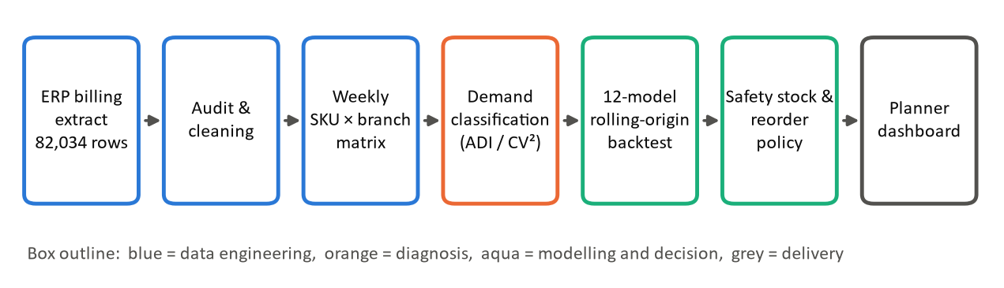
Figure 4.1: Analytical pipeline from raw billing lines to replenishment policy
Source: Team analysis.

Candidate methods
We selected candidates to span the families the literature recommends for this kind of demand (Chapter 2), from the simplest rules a planner might use to a global machine-learning model:
- Baselines: naive (next week equals last week), seasonal naive (same week last year), an eight-week moving average, and simple exponential smoothing (SES) with a smoothing constant of 0.2.
- Statistical: ARIMA(1,1,1), fitted to each series separately (Box et al., 2015).
- Intermittent-demand: Croston's method, SBA and TSB, each with a smoothing constant of 0.1, plus a seasonal SBA that applies SBA to deseasonalised demand and rescales the result with a calendar-month index estimated from portfolio totals.
- Machine learning: a global LightGBM model and a global random forest, each trained on all series at once using the features described in Chapter 6.
- Ensemble: the simple average of LightGBM and the seasonal SBA, defined before any results were seen.

Rolling-origin evaluation
Each method forecasts one to four weeks ahead from eight forecast origins spaced four weeks apart, the first in the week ending 26 November 2023 and the last in the week ending 09 June 2024 (Figure 4.2). At each origin, a method sees only data from earlier weeks: statistical models are refitted, and the machine-learning models are retrained on examples whose target weeks fall entirely before the origin; this is the time-series analogue of cross-validation (Hyndman & Athanasopoulos, 2021). The test windows together cover 32 consecutive weeks spanning the December spike, the 2024 summer peak and the post-season decline, the periods in which forecasting matters most. A series is scored at an origin once it has at least eight weeks of sales history; newer series are handled by a fallback rule in deployment.
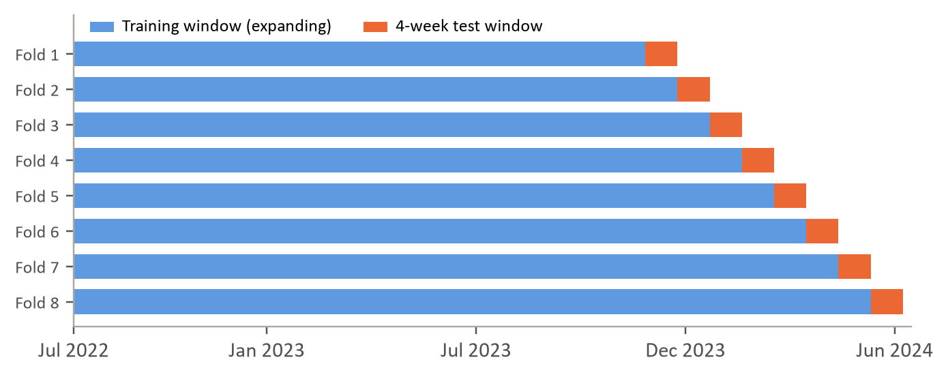
Figure 4.2: Rolling-origin backtest design: eight expanding training windows, each followed by a four-week test window
Source: Team analysis.

Metrics and selection
Our primary metric is WAPE, computed across all scored series and weeks so that high-volume series carry proportionate weight. We also report bias (total forecast minus total actual, as a percentage of actual) to show whether a method systematically over- or under-forecasts, and MASE to compare errors on a scale-free basis (Hyndman & Koehler, 2006). Because planners act on lead-time totals rather than single weeks, we also compute WAPE on four-week sums per series and on branch-week totals. We did not use MAPE, which is undefined whenever actual demand is zero. The overall winner is the method with the lowest WAPE across all folds; separately, we test whether choosing a method for each series on the first four folds beats a single method on the last four.

From forecast error to safety stock
For each leading method, we estimated each series' weekly forecast error from the first four folds and set a safety stock of z × σ × √L, where σ is the root-mean-square weekly error, L is the two-week lead time and z = 1.645 corresponds to a 95% cycle service level (Silver et al., 2017). We then tested these buffers on the last four folds, March to June 2024, recording how often two-week demand exceeded forecast plus buffer (the achieved cycle service level), the share of units served from cover (fill rate), and the stock left over at the end of each cycle. This calibrate-then-test design ensures that buffer performance is also measured out of sample.

Tools and technologies
All analysis was carried out in Python. We used pandas for data preparation, statsmodels for ARIMA (Seabold & Perktold, 2010), scikit-learn for the random forest (Pedregosa et al., 2011), LightGBM for gradient boosting (Ke et al., 2017) and matplotlib for exhibits. The planner dashboard is built in Streamlit with Plotly charts. We chose this stack because it is open-source, widely supported and runs on a standard laptop: the full backtest of twelve methods across eight folds completes in about four minutes, short enough to rerun every week.
We considered and set aside two alternatives. Deep-learning sequence models generally need far longer histories than 103 weeks to outperform tree ensembles, and are harder for planners to interrogate. Hierarchical reconciliation (for example, MinT; Wickramasuriya et al., 2019) is implemented in the project codebase but was not part of the final evaluation, because the immediate decision is at SKU × branch level, where bottom-up branch and regional totals are coherent by construction.

Key Takeaways
- Every method was judged the way it would be used: forecasting four unseen weeks from eight successive origins spanning the 2023-24 season.
- The assumption most likely to move the results is the treatment of the April to June 2024 duplicates, which changes recent demand by about a quarter.

Chapter 5: Exploratory Data Analysis
Exploratory analysis answered one question for the rest of the project: what must a forecasting method cope with? The answer has four parts: a data structure that changes in the final quarter, a seasonal profile with two peaks, a demand base concentrated in a few models, branches and customers, and series so sparse that most weeks record no sale at all.

5.1 Data Quality and Cleaning
Table 5.1 lists the quality issues we found and how each was treated, and Figure 5.1 traces the resulting reduction from 82,034 raw rows to 66,336 positive outdoor-unit demand lines carrying 698,904 units.
Table 5.1: Data quality issues and their treatment
Issue | Extent | Treatment
Exact duplicate rows | 4,463 rows (5.44%), all Apr-Jun 2024, in groups of two to six or more identical lines | Removed; sensitivity reported below
Indoor-unit lines | 9,585 lines after de-duplication, all Apr-Jun 2024 | Set aside; IDU demand is paired with ODU demand
Returns and credit notes | 1,406 ODU lines, 5,820 units (0.83% of units) | Excluded from demand; reported separately
Zero-quantity lines | 243 ODU lines | Removed (no demand recorded)
Blank invoice, item, storage and dealer fields | All 23,603 rows of Apr-Jun 2024 | Fields not used for modelling; flagged to sponsor
Redundant and empty columns | 3 duplicate columns; 1 column 99.8% empty | Dropped
Inconsistent labels | 41 rows with '3 star' vs '3 Star' | Standardised
Blank trailing row | 1 row | Removed
Source: Sponsor ERP billing extract, July 2022 - June 2024; team analysis.
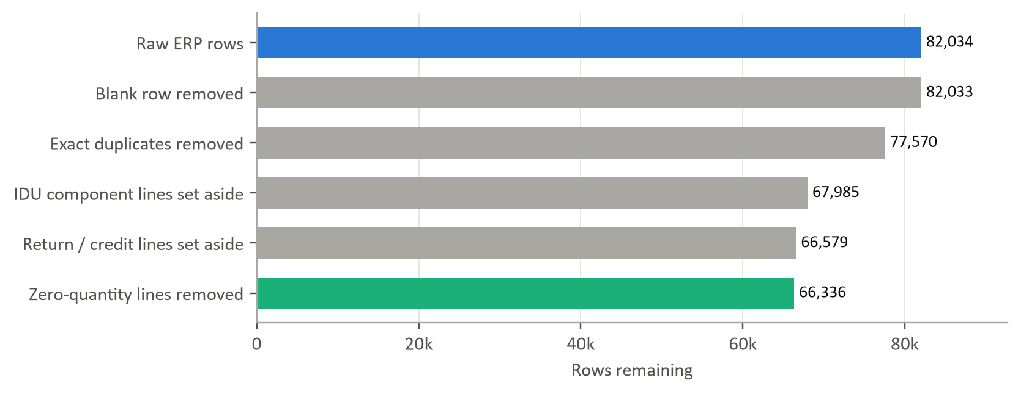
Figure 5.1: From raw ERP rows to outdoor-unit demand lines
Source: Sponsor ERP billing extract, July 2022 - June 2024; team analysis.
The duplicate decision deserves scrutiny because it cannot be verified from the data alone. Without invoice numbers, two identical lines in April to June 2024 could be one sale extracted twice or two genuine sales of the same model to the same buyer on the same day. Two facts favour removal: the first 21 months, which carry invoice numbers, contain no exact duplicates at all, and some lines repeat five or six times, which is implausible for genuine orders. Keeping the duplicates would raise April to June 2024 outdoor-unit volume by 26%, from 137,992 to 174,268 units. We therefore treat our de-duplicated figures as the conservative estimate, and recommend that the sponsor resolve the question from source invoices (Chapter 9).
A related correction concerns earlier project work. Interim analyses counted all 154 material codes as separate products and added indoor-unit to outdoor-unit quantities. Because indoor lines exist only from April 2024, that definition doubled apparent demand in the final quarter and, by adding 84 indoor codes with only 13 weeks of history, overstated the share of sparse series. All figures in this report use the corrected definition and supersede those interim figures.

5.2 Volume over Time and Seasonality
Weekly demand is highly volatile even at portfolio level: the coefficient of variation of weekly volume is 0.91, and weekly totals ranged from 136 to 24,938 units (Figure 5.2). The business also grew rapidly: outdoor-unit volume from July to March rose 68.1% from 2022-23 to 2023-24, and April to June 2024 was 49.1% above the same quarter of 2023 even after removing duplicates. A forecasting method that anchors on last year's level, such as a seasonal naive rule, will therefore under-forecast systematically.
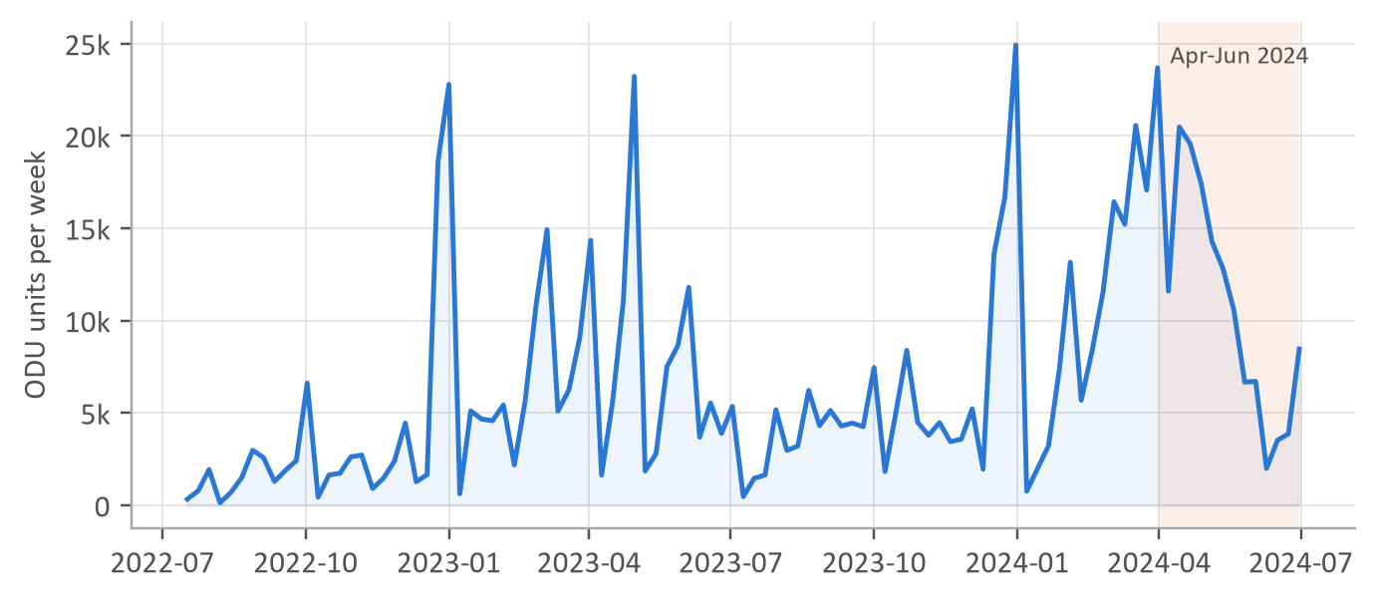
Figure 5.2: Weekly outdoor-unit demand across all branches and models
Source: Sponsor ERP billing extract, July 2022 - June 2024; team analysis.
Figure 5.3 expresses each calendar month's volume as a ratio to the average month, separately for each year. Two peaks are clear. The summer peak runs from February to May, which together account for 54.8% of annual volume, with March and April at about twice the monthly average. A second, sharp peak in December (14.5% of volume) coincides with year-end billing rather than weather, and is consistent with channel stocking by dealers. The monsoon trough is deep: July runs at 0.14 to 0.3 times the average month. The shape is stable across the two years, but the timing shifted: in 2024 the peak arrived earlier and was more concentrated in March and April.
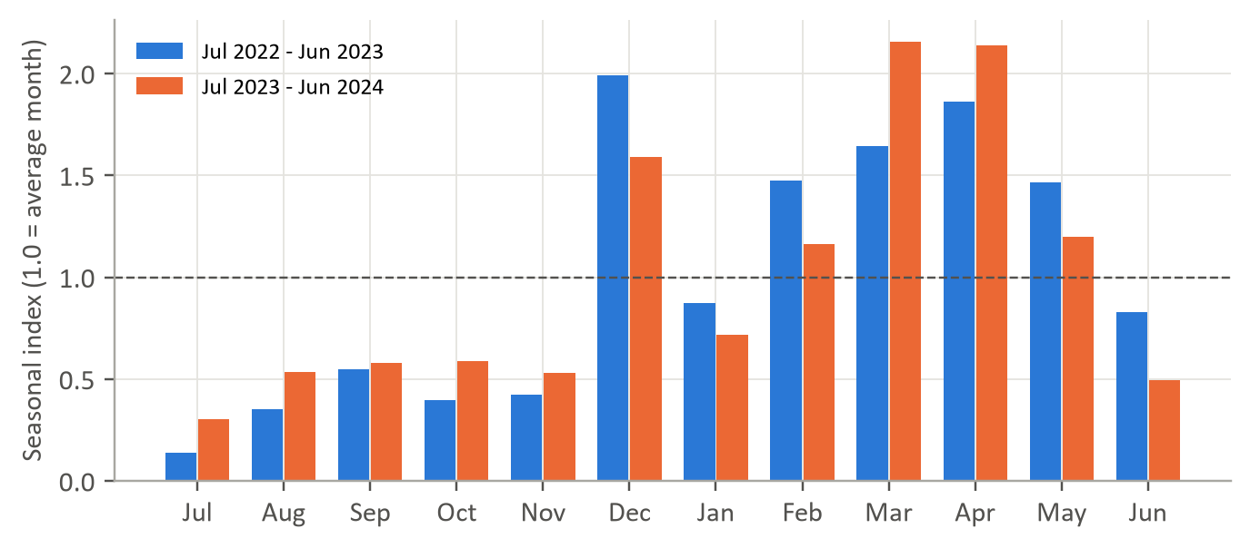
Figure 5.3: Seasonal index of outdoor-unit volume by calendar month, two years compared
Source: Sponsor ERP billing extract, July 2022 - June 2024; team analysis.

5.3 Branches
Volume is concentrated in two branches: MAA accounts for 35.1% and SBD for 28.3% of outdoor-unit volume (Figure 5.4). Growth, however, is fastest in the smaller branches: COK grew 144% and SBD1 121% between the July-to-March periods of the two years, compared with about 50% for the larger branches. Fast growth erodes the value of history, because last year's pattern describes a smaller business, so these branches are where a forecast that adapts quickly to recent levels matters most.
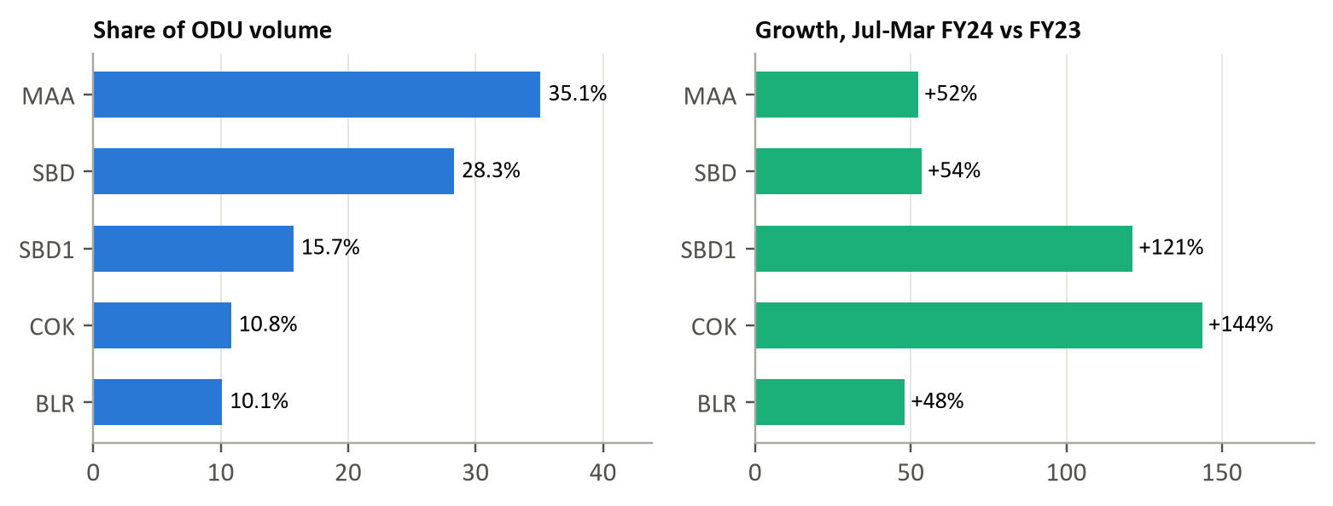
Figure 5.4: Branch share of outdoor-unit volume and year-on-year growth
Source: Sponsor ERP billing extract, July 2022 - June 2024; team analysis.

5.4 Products and Customers
Demand is concentrated in a small number of models. Of 70 outdoor models, 16 account for 80% of volume and the top ten for 66.4% (Figure 5.5). The portfolio is dominated by inverter models (80.7% of volume), by the 3-star and 5-star inverter ratings, and by the 1.5-ton capacity, which alone accounts for 65.6% (Figure 5.6). Customer demand is also concentrated: the ten largest of 2,351 customers account for 36.6% of units and the top 50 for 67.3%. A single large dealer order can therefore dominate a model's week at a branch, which is one source of the lumpiness discussed next.
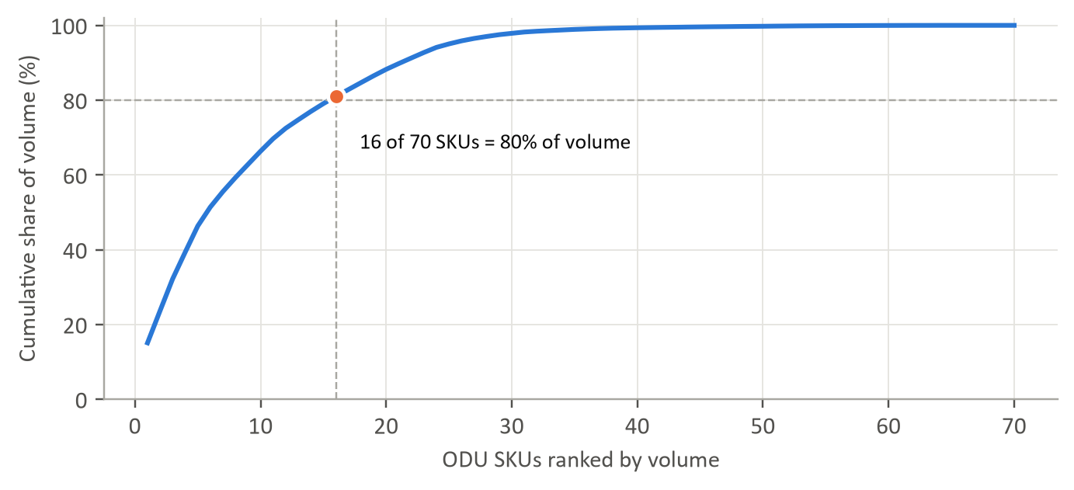
Figure 5.5: Cumulative share of outdoor-unit volume by SKU (Pareto curve)
Source: Sponsor ERP billing extract, July 2022 - June 2024; team analysis.
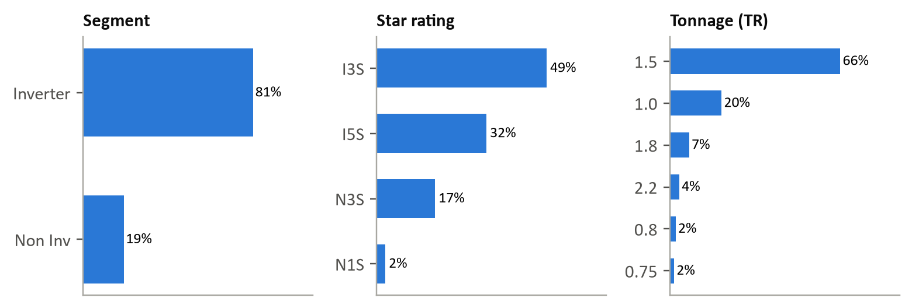
Figure 5.6: Outdoor-unit volume by segment, star rating and tonnage
Source: Sponsor ERP billing extract, July 2022 - June 2024; team analysis.

5.5 Order Sizes and Intermittency
Invoice lines are small and highly skewed: the median line is 4 units, the mean 10.54, and the 99th percentile 120, with a skewness of 4.07 (Figure 5.7, left). 36% of lines are for one or two units. Aggregated to weeks, most model-branch series record no sale in most weeks: the median series is zero in 64.5% of the weeks since its first sale (Figure 5.7, right). The distribution is bimodal: a small group of core models sells nearly every week, while a large tail sells only occasionally.
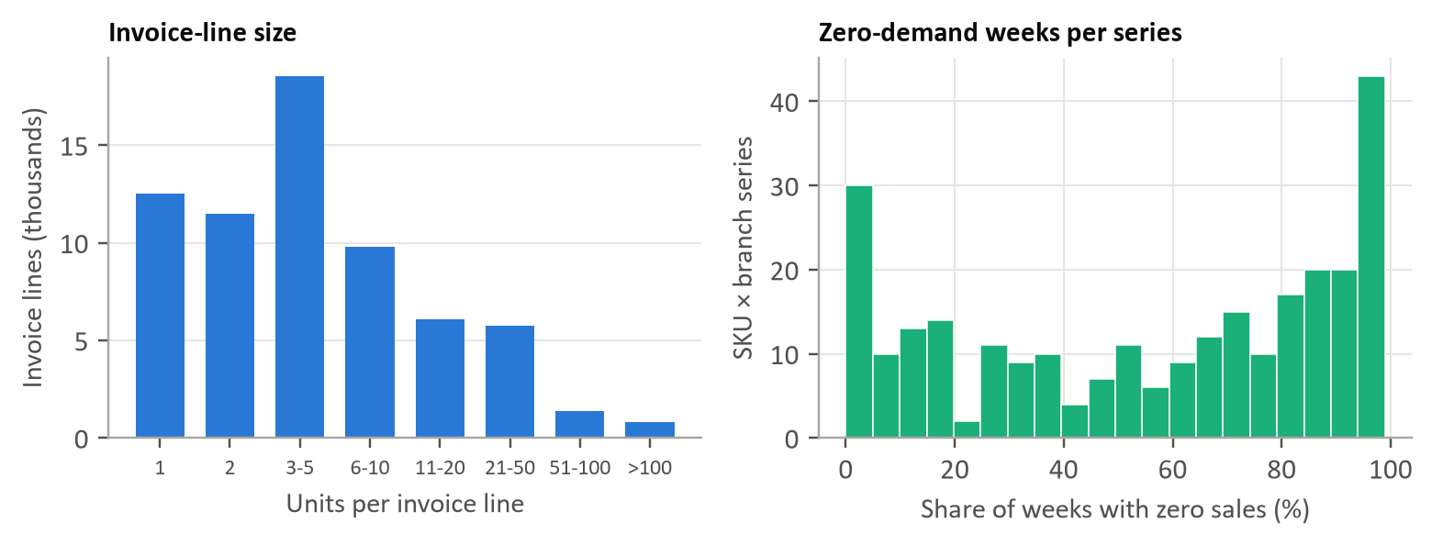
Figure 5.7: Invoice-line size and the share of zero-demand weeks per SKU × branch series
Source: Sponsor ERP billing extract, July 2022 - June 2024; team analysis.

5.6 Demand Classification
Figure 5.8 places each of the 273 SKU × branch series on the Syntetos-Boylan axes, and Table 5.2 summarises the result. Half of the series (50.9%) are lumpy and a further 23.8% intermittent; only 12 series are smooth. Volume tells a different story: the 57 erratic series, which sell most weeks but in widely varying quantities, carry 59.8% of units, while the 65 intermittent series together carry under 1%. At SKU level (all branches combined), 34 of 70 models are lumpy, 22 erratic, 9 intermittent and 5 smooth.
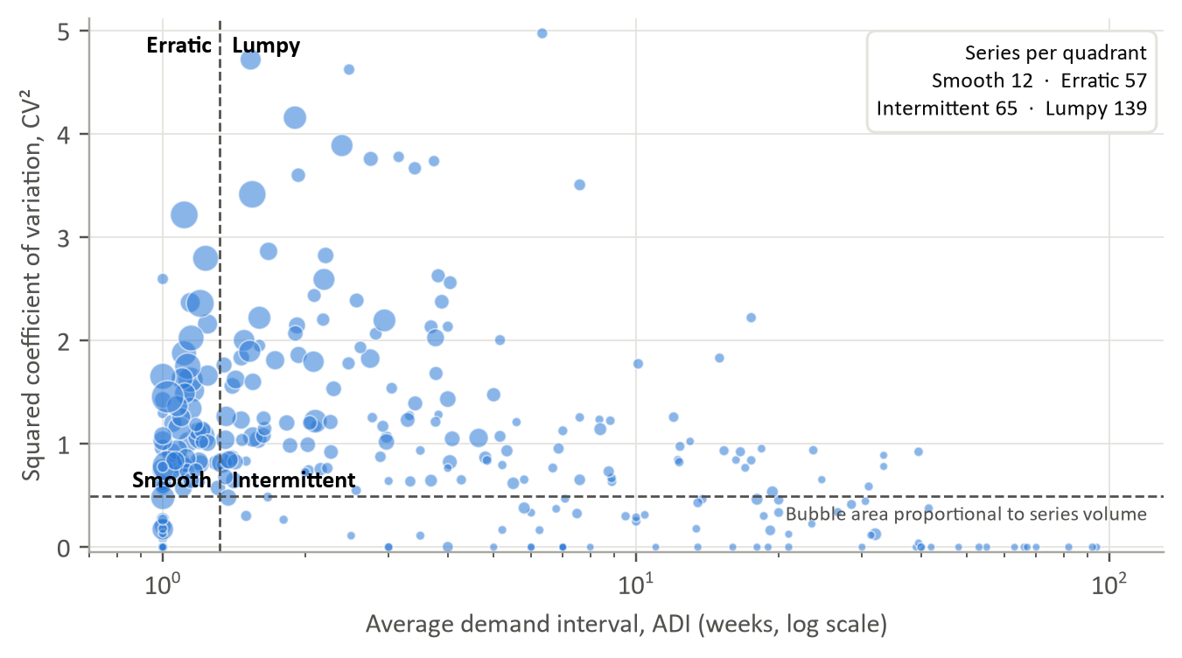
Figure 5.8: Syntetos-Boylan classification of SKU × branch demand series
Source: Sponsor ERP billing extract, July 2022 - June 2024; team analysis.
Table 5.2: Demand classes: number of series and share of volume
Demand class | Definition | Series | % of series | % of volume
Smooth | ADI < 1.32, CV² < 0.49 | 12 | 4.4 | 3.4
Erratic | ADI < 1.32, CV² ≥ 0.49 | 57 | 20.9 | 59.8
Intermittent | ADI ≥ 1.32, CV² < 0.49 | 65 | 23.8 | 0.8
Lumpy | ADI ≥ 1.32, CV² ≥ 0.49 | 139 | 50.9 | 35.9
Total |  | 273 | 100.0 | 100.0
Source: Sponsor ERP billing extract, July 2022 - June 2024; team analysis.
The practical message is that no single classical method suits the portfolio. Methods designed for intermittent demand fit most series but little of the volume; methods for smooth demand fit almost none; and the erratic, high-volume series that matter most commercially combine frequent sales with sharp swings driven by seasonality and large orders. This mix is what motivated a method that can learn across series rather than one tuned to a single demand class.

Key Takeaways
- Sixteen models and two branches drive most of the volume, but three in four model-branch series are lumpy or intermittent, and the median series records no sale in 64% of weeks.
- Demand peaks twice, in February to May and in December, and the 2024 peak came earlier; methods anchored on last year's level or on recent averages will miss the turning points.
- The April to June 2024 duplicates change recent volume by about a quarter and must be resolved at source.

Chapter 6: Feature Selection and Engineering
For the statistical and intermittent-demand methods, the only input is a series' own history. The machine-learning models, by contrast, are only as good as the features they are given, and in a time-series setting every feature is also an opportunity to leak information from the future. This chapter explains which features we built, which we dropped, and how we kept every feature strictly backward-looking.

6.1 Target and Training Design
The target is weekly outdoor-unit demand for one SKU at one branch. We use a direct multi-horizon design: one model predicts demand one, two, three or four weeks after a forecast origin, using only information available at the origin, with the horizon itself supplied as a feature. Each training example therefore pairs a feature vector computed at some past origin with the actual demand some weeks later. At the last backtest origin, the model trains on 57,216 such examples drawn from all series, compared with at most about a hundred weekly observations for any single series. This pooling is what allows a global model to learn the shape of the season from all series at once (Montero-Manso & Hyndman, 2021).
Weekly demand is non-negative, zero-inflated and right-skewed. Rather than transform the target, we trained LightGBM with a Tweedie loss, which is designed for exactly this mix of many zeros and occasional large values, with a variance power of 1.3. The random forest, which has no such loss, was trained on squared error.

6.2 Engineered Features
We engineered 31 features in six groups (Table 6.1). Every feature is computed from weeks before the forecast origin, except calendar features of the target week, which are known in advance.
Table 6.1: Engineered features, rationale and leakage control
Group | Features | Rationale | Leakage control
Recent level | Demand lags of 1, 2, 3, 4, 6, 8 and 12 weeks; rolling means over 4, 8, 13 and 26 weeks | Captures the current run-rate at several speeds | All windows end the week before the origin
Volatility and intermittency | 8-week rolling standard deviation; share of non-zero weeks in 13 weeks; weeks since last sale | Lets the model temper forecasts for sporadic series | Computed on pre-origin weeks
Seasonality | Same week last year; 3-week mean around it; year-on-year ratio of recent level; calendar-month seasonal index; week-of-year sine and cosine; target month | Encodes the two seasonal peaks and growth | Last-year values lie at least 48 weeks before the origin; the month index uses pre-origin data only
Network context | Portfolio 4-week mean; portfolio volume same week last year; branch 4-week mean | Shares signal from the wider network, e.g. an early season | Pre-origin weeks only
Product and branch | SKU, branch and star rating (categorical); tonnage; inverter flag | Lets the model learn persistent differences | Static attributes
Life-cycle and horizon | Weeks since the series' first sale; forecast horizon (1-4) | Distinguishes new from mature models; error grows with horizon | Known at origin
Source: Team analysis.

6.3 Features Dropped and Encoding Choices
We deliberately excluded several fields. Customer and dealer identities were excluded both because they are personal or commercially sensitive and because the identity of next week's buyers is not known in advance. Invoice and line numbers, storage location, the constant product-family fields (SBU and MatGroup3), the duplicated columns and the text labels for year, month and week carry no information beyond the billing date. Indoor-unit quantities were excluded because they exist only in the final quarter and mirror outdoor-unit quantities.
Because both machine-learning models are tree ensembles, no scaling or normalisation was needed: trees split on thresholds and are unaffected by monotonic transformations. LightGBM handled SKU, branch and star rating natively as categorical variables; for the random forest we used integer codes. Lags that reach back before a series' first sale were left missing for LightGBM, which learns a default direction for missing values, and set to a sentinel value for the random forest. We did not use dimensionality reduction: with 31 interpretable features and tens of thousands of training rows, it would have cost interpretability without a clear gain.

6.4 Which Features Mattered
Figure 6.1 ranks the features by their share of LightGBM's total split gain, averaged over the eight training folds. Recent level dominates: the rolling means and lags together account for 56% of the gain, led by the 8-week rolling mean alone at 29.5%. Product and branch identity contribute 18%, seasonality and calendar features 17%, and volatility 10%. Two observations follow. First, smoothed run-rates are far more informative than any single lag: one week's sales is too noisy to anchor a forecast, which is also why the naive rule performs poorly beyond one week. Second, the seasonal features, although smaller in aggregate, are what allow the model to anticipate the end of the peak; Chapter 7 shows that this is precisely where it gains most over simple averages.
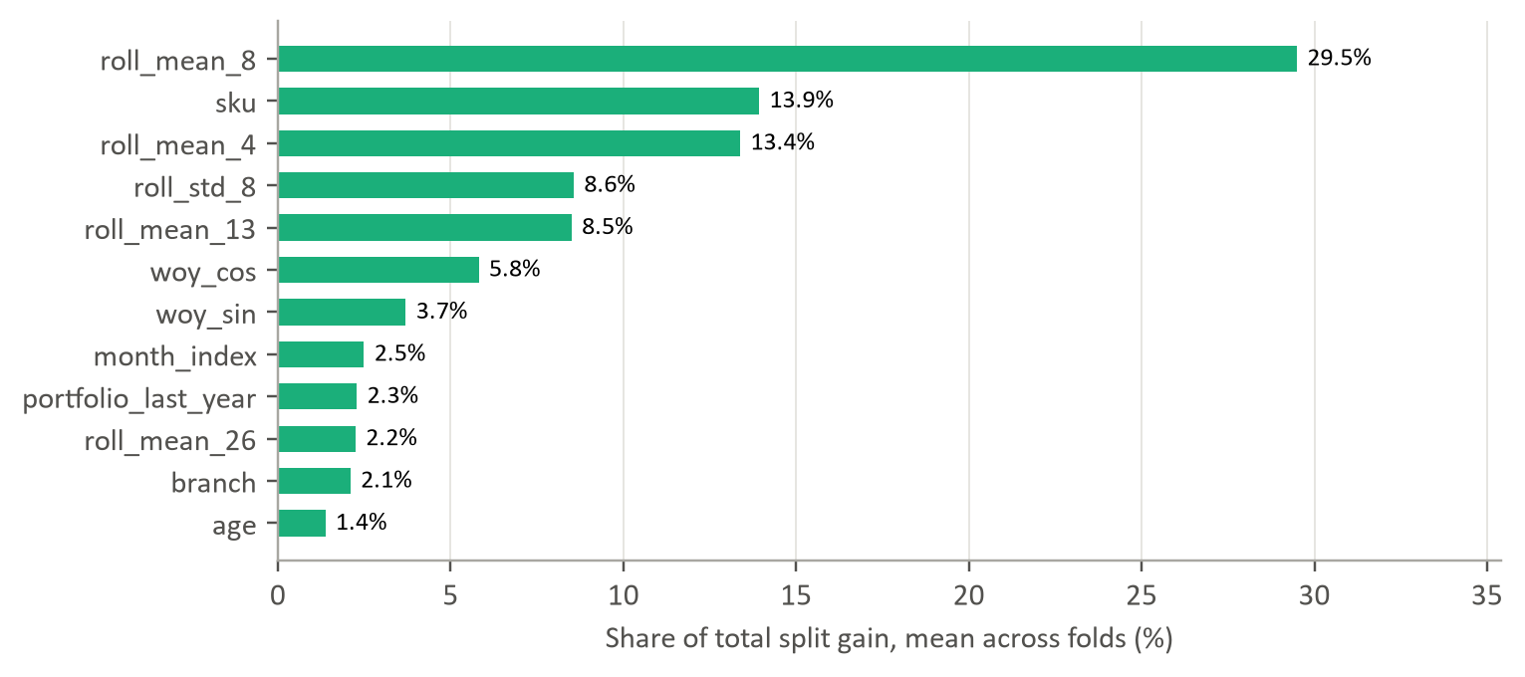
Figure 6.1: LightGBM feature importance: share of split gain, mean of eight folds
Source: Sponsor ERP billing extract; team rolling-origin backtest, 8 folds, weeks ending 26 Nov 2023 - 30 Jun 2024.
Leakage was guarded in three ways. Every feature was computed by functions that take the forecast origin as an argument and read only earlier weeks; training examples were restricted to target weeks before the origin; and the seasonal index was re-estimated at each origin from earlier data only. The project codebase also contains automated tests that check lag and rolling-window features for look-ahead (tests/test_leakage_audit.py).

Key Takeaways
- Smoothed recent run-rates (4- to 13-week means) carry most of the signal; together with lags they account for 56% of the model's split gain.
- Calendar and last-year features are a smaller share but are what let the model anticipate seasonal turning points that averages miss.

Chapter 7: Modelling and Results
The headline result is that a single global LightGBM model was the most accurate method on every aggregate measure, reducing weekly error by 19% relative to an eight-week moving average, but that weekly demand at SKU × branch level remains difficult for every method. This chapter explains which models we compared and why, which we shortlisted, and what the results mean for the sponsor.

7.1 Models and Metrics Considered
Table 7.1: Models and metrics considered
Model | Brief approach | Metric(s) and why | Challenges
Naive; seasonal naive | Repeat last week, or the same week last year | Benchmarks: any useful method must beat them on WAPE | Naive chases noise; seasonal naive ignores 50-70% growth
Moving average (8w); SES | Average or exponentially weighted average of recent weeks | Proxy for planners' current rules | Lag behind seasonal turns; flat over the horizon
ARIMA(1,1,1) | Per-series autoregressive model on differenced demand | WAPE and bias; classical statistical benchmark | Unstable on short, sparse series; needed zero-bounding
Croston; SBA; TSB | Smooth demand size and interval (or probability) separately | WAPE and MASE; designed for intermittent demand | Flat forecasts with no seasonality
Seasonal SBA | SBA on deseasonalised demand, rescaled by a calendar-month index | Tests whether adding seasonality rescues intermittent methods | Month index from one to two years of data
Random forest (global) | Bagged regression trees on 31 features across all series | WAPE and bias; non-linear benchmark | Over-forecasts sparse series; no count-data loss
LightGBM (global) | Gradient-boosted trees with Tweedie loss on 31 features | WAPE, bias, MASE, aggregated WAPE | Needs feature pipeline and monitoring
Ensemble | Average of LightGBM and seasonal SBA | Tests whether combining families adds robustness | Inherits seasonal SBA's off-season bias
Source: Sponsor ERP billing extract; team rolling-origin backtest, 8 folds, weeks ending 26 Nov 2023 - 30 Jun 2024.
WAPE is our primary metric because it weights errors by volume, and units of stock are what the sponsor pays for; it also remains defined when actual demand is zero. Bias is reported because a forecast that is systematically low causes stock-outs at the peak however small its average error. MASE complements both by scaling each series' error by that of a naive forecast, which gives small series equal weight. Because the replenishment decision covers two to four weeks, we also report WAPE on four-week sums per series and on branch-week totals.

7.2 Models Chosen
Against these metrics we shortlisted three approaches. LightGBM is the primary candidate because it had the lowest WAPE overall, on four-week buckets and on branch totals, and its advantage held across branches and volume tiers. The seasonal SBA and the ensemble are retained as interpretable challengers: their logic, an intermittent level rescaled by a seasonal index, can be explained in one sentence to a planner, and the ensemble was close to unbiased overall (+2.1%) with the second-lowest WAPE. The moving average is retained as the fallback for series with too little history and as the benchmark that any deployed model must continue to beat.

7.3 Results

Overall accuracy
Table 7.2: Backtest results for all twelve methods (ranked by weekly WAPE)
Model | Weekly WAPE % | Bias % | MASE | 4-week bucket WAPE % | Branch-week WAPE %
LightGBM | 84.7 | -10.3 | 1.36 | 62.7 | 51.1
Ensemble (LightGBM + Seasonal SBA) | 94.0 | +2.1 | 1.48 | 69.2 | 51.4
SES | 98.8 | +4.0 | 1.37 | 73.6 | 67.4
Naive | 101.2 | -13.1 | 1.36 | 87.9 | 68.8
Random Forest | 102.7 | +26.7 | 3.09 | 74.7 | 62.0
ARIMA(1,1,1) | 103.1 | +4.9 | 1.36 | 79.2 | 67.4
TSB | 103.4 | +0.7 | 1.37 | 80.0 | 71.6
Moving Average (8w) | 104.8 | +10.1 | 1.41 | 81.9 | 73.7
Seasonal SBA | 110.2 | +14.5 | 1.66 | 81.8 | 59.5
SBA | 110.2 | +4.6 | 1.53 | 87.3 | 72.6
Croston | 112.6 | +10.1 | 1.56 | 89.0 | 73.8
Seasonal Naive | 139.5 | +32.6 | 1.55 | 119.1 | 72.1
Source: Sponsor ERP billing extract; team rolling-origin backtest, 8 folds, weeks ending 26 Nov 2023 - 30 Jun 2024.
Table 7.2 and Figure 7.1 report the results over 6,968 scored series-weeks for 233 series. Three findings stand out.
First, weekly SKU × branch demand is hard for every method. Even the best method has a weekly WAPE of 84.7%: on average, its absolute weekly error is close to the size of demand itself. This is the expected consequence of the sparsity documented in Chapter 5, where a single dealer order can make or break a model's week at a branch, and it is why decisions should not be taken on single-week, single-series forecasts. Aggregation helps substantially. Over four-week buckets, the level at which replenishment is actually committed, LightGBM's WAPE falls to 62.7%, and for branch-week totals to 51.1%.
Second, the global LightGBM model is best on every volume-weighted measure. Its weekly WAPE is 19% lower than the moving average's and 16% lower than the naive rule's. The margin widens with aggregation: 24% lower on four-week buckets and 31% lower on branch-week totals. The random forest, trained on the same features, did much worse (102.7% WAPE, +27% bias), mainly because it over-forecast sparse series; the count-appropriate Tweedie loss appears to matter as much as the features.
Third, the classical intermittent-demand methods did not help. Croston, SBA and TSB were no better than simple smoothing, and adding a seasonal index to SBA raised its bias without reducing its error. On MASE, which gives every series equal weight regardless of volume, LightGBM (1.36) merely ties the naive rule and ARIMA, signalling that its advantage is concentrated in the series that carry volume.
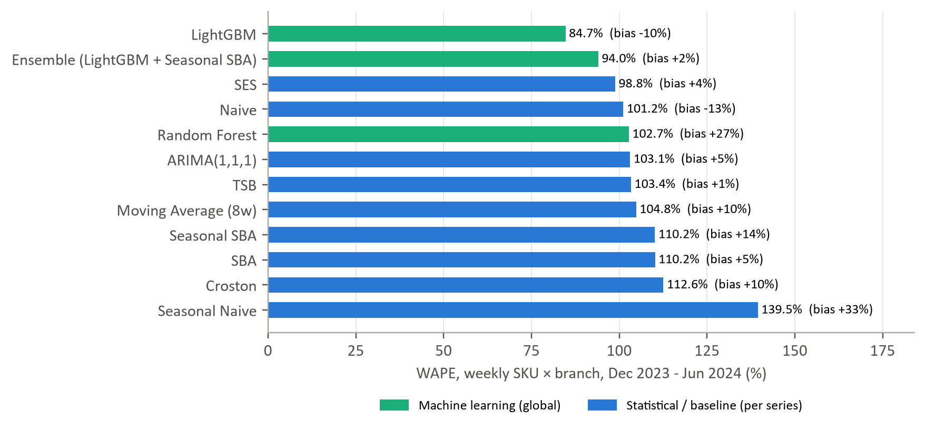
Figure 7.1: Weekly WAPE and bias by method
Source: Sponsor ERP billing extract; team rolling-origin backtest, 8 folds, weeks ending 26 Nov 2023 - 30 Jun 2024.

Where the advantage lies
Figure 7.2 breaks accuracy down by demand class. LightGBM has the lowest error for the erratic and lumpy series, which together carry 96% of volume. For the 12 smooth series the random forest is slightly better (28.0% against 32.7%), and for the 65 intermittent series, which carry under 1% of volume, the naive rule is marginally better. Table 7.3 confirms that the gain is greatest where it matters commercially. For the 54 "A" series that make up 80% of volume, LightGBM's WAPE is 79.4% against 100.6% for the moving average, a 21% reduction; in the long tail of "C" series, all methods are poor and LightGBM's advantage disappears.
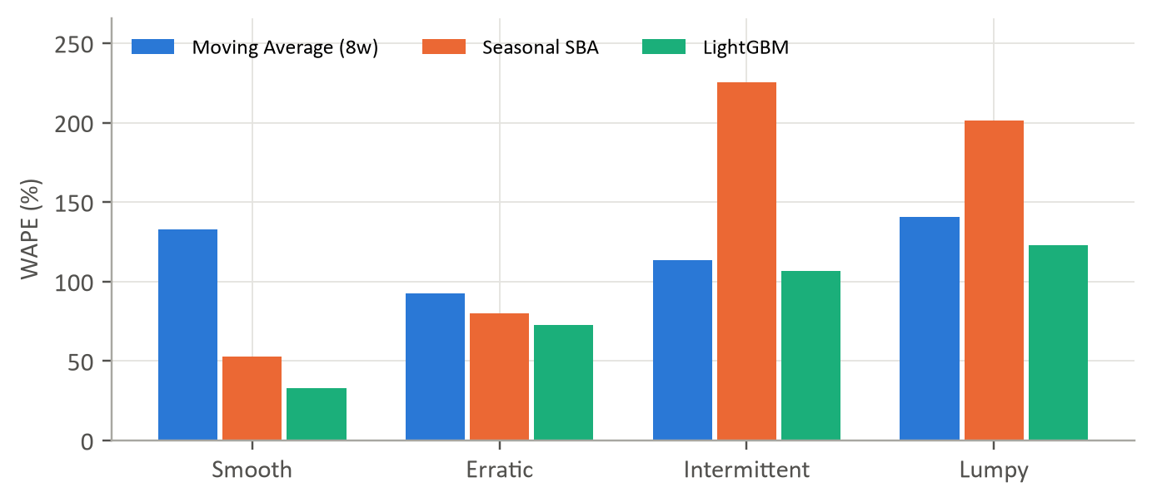
Figure 7.2: Weekly WAPE by demand class for three representative methods
Source: Sponsor ERP billing extract; team rolling-origin backtest, 8 folds, weeks ending 26 Nov 2023 - 30 Jun 2024.
Table 7.3: Weekly WAPE (%) by volume tier
Volume tier | Series | Naive | Moving average (8w) | SES | Seasonal SBA | LightGBM
A (top 80% of volume) | 54 | 97.5 | 100.6 | 94.5 | 98.9 | 79.4
B (next 15%) | 49 | 111.7 | 122.9 | 116.2 | 143.2 | 105.7
C (last 5%) | 170 | 163.5 | 150.6 | 151.6 | 302.0 | 149.5
Source: Sponsor ERP billing extract; team rolling-origin backtest, 8 folds, weeks ending 26 Nov 2023 - 30 Jun 2024.
Timing matters as much as product. Figure 7.3 overlays the aggregate forecasts on actual demand across the 32 test weeks. During the ramp-up from February to April 2024, the moving average and SES were as accurate as LightGBM (fold WAPEs of 66.3% for SES and 64.8% for LightGBM in the fold starting 17 March). The difference appears at the turning points. When the season ended in May and June, the averaging methods kept projecting peak-season volume, with fold WAPEs of 233% and 283% for the moving average, while LightGBM, informed by calendar and last-year features, followed demand down (144% and 94%). For a seasonal business, the end of the season is exactly when excess stock is created, so this is where accuracy is worth most.
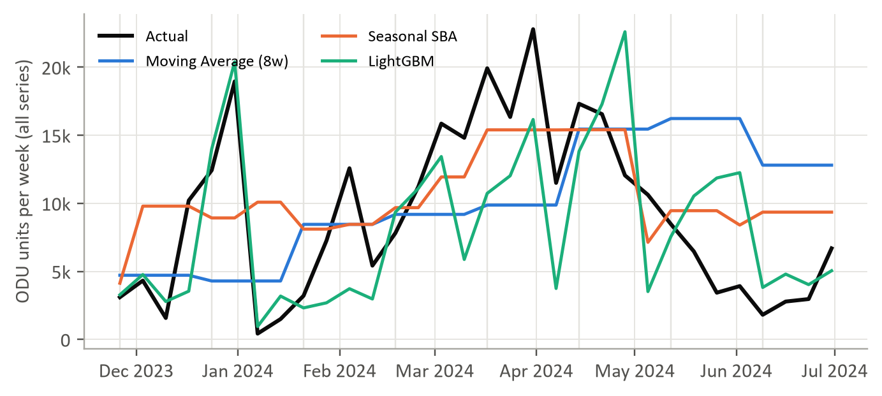
Figure 7.3: Actual versus forecast demand, all series combined, across the eight backtest folds
Source: Sponsor ERP billing extract; team rolling-origin backtest, 8 folds, weeks ending 26 Nov 2023 - 30 Jun 2024.
LightGBM's main weakness is bias at the peak. It under-forecast February-to-May demand by 17% while over-forecasting the off-season by 8%, whereas the moving average was nearly unbiased at the peak (-4%) but over-forecast the off-season by 48%. In 2024 the peak was earlier and steeper than in 2023, and a model that learns partly from last year's pattern adapts with a lag. The practical remedy, adopted in our recommendations, is to set peak-season buffers from errors measured in the peak itself.
Accuracy also decays with horizon (Figure 7.4). LightGBM's WAPE is about 72% one and two weeks ahead and rises to about 97% three and four weeks ahead. One week ahead, the naive rule is almost as good (73.3%), but it deteriorates quickly thereafter. With a two-week lead time, the one- and two-week horizons are the ones that drive replenishment.
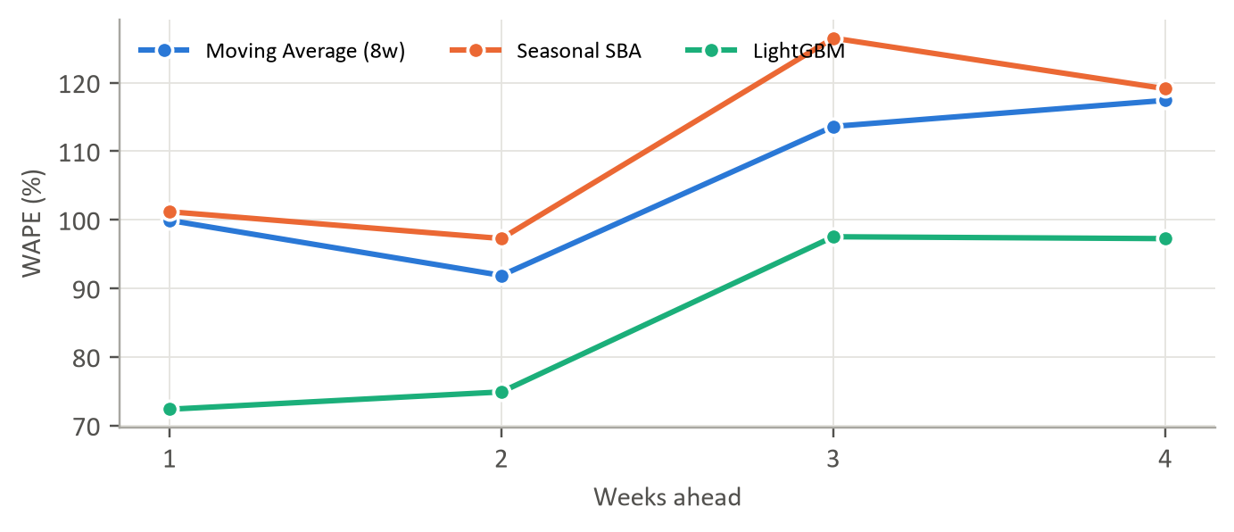
Figure 7.4: Weekly WAPE by forecast horizon
Source: Sponsor ERP billing extract; team rolling-origin backtest, 8 folds, weeks ending 26 Nov 2023 - 30 Jun 2024.

Does choosing a model per series help?
A common design, and the one used in the project dashboard's model tournament, picks the best method for each series from past accuracy. We tested this honestly: for each series we selected the method with the lowest error over the first four folds, then measured it on the last four. Naive and the moving average were selected most often (63 and 56 series), LightGBM for 31. The per-series selection achieved a WAPE of 98.6% over the last four folds, worse than applying LightGBM to every series (84.9%). With only a few months of sparse history per series, past winners are largely winners by chance; a single global model is both more accurate and simpler to govern.

Key Takeaways
- A single global LightGBM model is the most accurate method: 24% lower four-week-bucket error than the moving average, and 21% lower weekly error on the series that carry 80% of volume.
- Its edge is greatest at seasonal turning points, where averages over-forecast; its weakness is a lag at the start of an early, steep peak.
- Choosing a model per series on past accuracy is worse than one global model; weekly SKU × branch forecasts should inform, not dictate, decisions taken over four-week buckets.

Chapter 8: Deployment, Validation and Responsible AI
A forecast that is accurate in a backtest but misused in production does more harm than no forecast at all. This chapter describes how the model would reach planners, how it should be evaluated before it is trusted, where its risks lie, and how it should be monitored. Because the model forecasts products rather than people, the main responsible-AI questions concern consistency across branches and product groups, explainability to planners, and the integrity of the numbers shown to decision-makers.

8.1 Deployment and Evaluation
Current delivery vehicle. The project produced a Streamlit planner dashboard with twelve views in four groups: exploratory analysis (data quality radar, cleaning studio, statistical deep-dive and an explorer), SKU demand forecasting (forecast view, model leaderboard and hierarchical reconciliation), operations (forecast monitoring and drift, inventory intelligence and a scenario simulator) and executive reporting. It runs locally and has also been deployed as a hosted web application for sponsor demonstrations.
Proposed production path. We recommend a weekly batch rather than an interactive model. Each Monday, the latest week of billings is extracted, validated and appended to the weekly matrix; the global LightGBM model is retrained on all history (about four minutes on a laptop); and forecasts for the next four weeks, with error-based safety stocks, are written to a table that the dashboard and the planners' existing spreadsheets read. Series with fewer than eight weeks of history receive the moving-average forecast until they qualify. Planners can review and override forecasts, and every override is logged so that its value can be measured, as recommended by Fildes et al. (2009).
Evaluation before reliance. The backtest establishes that the model beats simple rules on history; it does not establish that it beats experienced planners. We therefore recommend a shadow pilot of at least twelve weeks, covering the February-to-May 2027 peak, at MAA (the largest branch) and COK (the fastest-growing). During the pilot, planners continue to decide as today while the model's forecasts are recorded alongside theirs; the comparison of four-week-bucket WAPE, bias and stock outcomes then decides whether to scale.
A required correction to the dashboard. Our audit found that the dashboard's model leaderboard fits each candidate model on a SKU's full history and scores it on the same weeks, and that its accuracy display substitutes a bounded proxy whenever WAPE exceeds 100%. Both practices overstate accuracy relative to the out-of-sample figures in Chapter 7. Before planners use the leaderboard, it must be rebuilt on the rolling-origin results, and the synthetic test records noted in Section 3.3 must be removed from its data file.

8.2 Fairness, Explainability and Risk
Consistency across branches and product groups. The model makes no decisions about individuals, so classical fairness metrics do not apply. The relevant question is whether forecast quality, and hence service, is systematically worse for some branches or products. Table 8.1 shows that LightGBM improves on the moving average in every branch, with WAPE ranging from 75.9% to 89.3%. COK, the fastest-growing branch, has the highest error under both methods, which is consistent with growth eroding the value of history. Across demand classes and volume tiers (Section 7.3), the long tail of sporadic series is forecast poorly by every method; for these, the fair and efficient response is a simple rule and a modest buffer rather than false precision.
Table 8.1: Weekly WAPE (%) by branch
Branch | Share of volume % | Naive | Moving average (8w) | SES | LightGBM | LightGBM vs moving average
MAA | 35.1 | 97.3 | 113.4 | 105.7 | 88.1 | -22%
SBD | 28.3 | 109.6 | 96.3 | 91.2 | 83.4 | -13%
SBD1 | 15.7 | 91.3 | 96.1 | 91.0 | 75.9 | -21%
COK | 10.8 | 111.8 | 116.1 | 109.9 | 89.3 | -23%
BLR | 10.1 | 94.4 | 102.2 | 98.0 | 86.6 | -15%
Source: Sponsor ERP billing extract; team rolling-origin backtest, 8 folds, weeks ending 26 Nov 2023 - 30 Jun 2024.
Explainability. A planner needs to understand why a forecast is high or low before acting on it. Three layers of explanation are available. Globally, the feature importances in Chapter 6 show that the model is driven mainly by recent run-rates, adjusted for seasonality and product identity, which matches planners' own intuition. For an individual forecast, the dashboard can show the inputs that matter most (the 4-, 8- and 13-week averages, last year's demand in the same weeks and the seasonal index) next to the forecast, and SHAP values (Lundberg & Lee, 2017) can attribute a specific forecast to its features. Finally, the seasonal SBA challenger provides a transparent cross-check: where the two disagree sharply, the forecast should be reviewed.
Risks the sponsor should know about.
- Censored demand: billings understate demand when stock ran out, so the model learns to under-forecast exactly the models that sell out; peak-season bias of about -17% is partly this effect.
- Structural breaks: the April 2024 change in extract structure shows that upstream system changes can silently alter the data; automated checks (Section 8.3) must catch such breaks before retraining.
- Season-start lag: in an early or unusually hot season, the model adapts with a lag; peak buffers should be set from peak-season errors, and planners should be able to apply an explicit seasonal uplift.
- New products: models with little history are forecast by a fallback rule; launches need planner input.
- Automation bias: a confident-looking dashboard can lead planners to accept forecasts uncritically; showing error bands and logging overrides keeps judgement in the loop.

8.3 Monitoring Plan
The project codebase already contains drift and tracking-signal monitors, but their default health thresholds (for example, WAPE below 25% counts as healthy) were set without reference to the achievable accuracy for this portfolio and would flag every series permanently. We recommend relative thresholds, anchored on the backtest, as set out in Table 8.2.
Table 8.2: Monitoring metrics, triggers and actions
What is monitored | Frequency | Trigger | Action
Data integrity: duplicates, blank invoice numbers, ODU/IDU structure, negative quantities | Every load | Any exact duplicate, blank key field or new line type | Block the load; alert data owner
4-week-bucket WAPE by branch vs. moving-average benchmark | Weekly (rolling 8 weeks) | Model worse than benchmark for 2 consecutive periods | Planner review; investigate features and data
Bias by branch, peak vs. off-peak | Weekly | Tracking signal beyond ±4 (cumulative error ÷ mean absolute error) | Recalibrate buffers; consider seasonal uplift
Demand distribution drift | Monthly | Population stability index above 0.25 vs. training window | Retrain and re-run backtest before release
Achieved cycle service and fill rate | Monthly | Cycle service more than 3 points below target | Recompute safety stocks from recent errors
Planner overrides | Monthly | Overrides that worsen accuracy on balance | Review override guidance
Source: Team analysis.
The model is retrained weekly as part of the batch. A full rolling-origin backtest should be repeated monthly and before any change to features or parameters, so that each released model version carries out-of-sample evidence.

Key Takeaways
- The single biggest deployment risk is false confidence: the dashboard currently shows in-sample accuracy and contains synthetic test records, both of which must be fixed before planners rely on it.
- Mitigation: release forecasts through a weekly batch with out-of-sample monitoring, and prove value in a shadow pilot at MAA and COK through the 2027 peak.

Chapter 9: Business Impact and Recommendations
For the manufacturer, a forecast is worth what it changes in inventory and service. The clearest measurable effect of moving from the moving-average rule to the global model is less excess stock at the same service: about 5,336 fewer units of surplus cover across the network at the end of each two-week cycle, roughly 19% less. This chapter quantifies that effect, sets out our recommendations, and lays out a roadmap.

9.1 Recommendations and Business Impact

Quantifying the inventory effect
Using the method described in Section 4.2, we set safety stocks from each method's own forecast errors in December 2023 to February 2024 and tested them from March to June 2024 across 204 series with sufficient history. Table 9.1 and Figure 9.1 summarise the results.
Table 9.1: Out-of-sample inventory performance of error-based safety stocks, March to June 2024
Forecast method | Safety stock (units) | Cycle service % | Unit fill rate % | Excess cover per cycle (units)
Naive | 27,038 | 90.4 | 85.7 | 27,947
Moving Average (8w) | 23,345 | 92.2 | 87.8 | 27,804
SBA | 25,221 | 90.7 | 82.9 | 28,388
Seasonal SBA | 26,819 | 92.2 | 85.9 | 30,955
LightGBM | 23,066 | 92.6 | 87.8 | 22,468
Ensemble (LightGBM + Seasonal SBA) | 23,619 | 91.9 | 86.5 | 25,447
Source: Sponsor ERP billing extract; team rolling-origin backtest, 8 folds, weeks ending 26 Nov 2023 - 30 Jun 2024. Lead time 2 weeks; 95% target cycle service level.
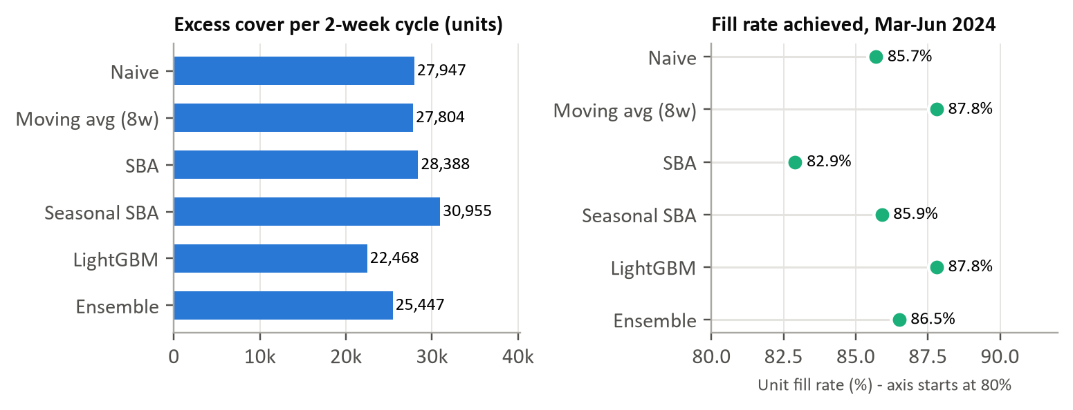
Figure 9.1: Excess cover and fill rate by forecast method, March to June 2024
Source: Sponsor ERP billing extract; team rolling-origin backtest, 8 folds, weeks ending 26 Nov 2023 - 30 Jun 2024.
Three results matter. First, the global model achieves the same fill rate as the moving average (87.8%) with slightly less safety stock and 19% less excess cover: the gain comes mainly from not over-forecasting after the peak, the error pattern documented in Chapter 7. Second, no method reached the 95% cycle-service target in this period; the best achieved 92.6%. The March-to-June 2024 window contained the earliest and steepest peak in the data, so buffers calibrated on the preceding winter were too small, which is why buffers must be recalibrated as the season turns. Third, the classical intermittent methods (SBA and seasonal SBA) delivered worse service with more stock, confirming that the accuracy ranking carries through to inventory outcomes.
Financial translation (indicative). At the project's working assumption of ₹25,000 per unit, 5,336 fewer units of surplus cover correspond to about ₹13.3 crore less stock positioned at any time, and, at a 15% annual holding cost, about ₹2.0 crore a year in carrying cost. These figures exclude two benefits we could not measure from billing data, fewer emergency inter-branch transfers and fewer lost peak-season sales, and depend on assumptions that the manufacturer should replace with its own costs.

Recommendations
- Repair the data foundation before scaling. Recover invoice numbers for April to June 2024 to settle whether the 4,463 duplicate lines (36,276 units, about a quarter of that quarter's volume) are real; formally adopt the outdoor unit as the unit of demand; and add automated integrity checks to every data load. Impact: removes the largest single uncertainty in recent demand.
- Adopt the global LightGBM model as the weekly baseline forecast. Run it as a weekly batch at SKU × branch level, with the moving average as fallback for series with fewer than eight weeks of history, and commit replenishment on four-week buckets. Impact: about 24% lower four-week-bucket error than the moving average.
- Set safety stocks from measured forecast error, recalibrated monthly and separately for the peak. Use each series' recent out-of-sample errors (or their empirical quantiles) rather than fixed cover rules. Impact: about 19% less excess cover at equal fill rate; indicatively ₹2.0 crore a year in carrying cost.
- Pilot in shadow mode at MAA and COK through the February-to-May 2027 peak before planners rely on the model. Impact: tests the model against planners' actual forecasts rather than proxies.
- Correct the dashboard before wider use. Replace the in-sample leaderboard with rolling-origin results, remove the synthetic test records and adopt the relative monitoring thresholds in Table 8.2. Impact: prevents overstated accuracy from reaching decision-makers.
- Concentrate planner attention where volume is. The 16 models that make up 80% of volume merit weekly review; the long tail of sporadic series should run on simple rules with modest buffers. Impact: better use of scarce planning time.

9.2 Implementation Roadmap
Table 9.2: Implementation roadmap
Recommendation | Owner | Timeline | Expected impact
1. Repair data foundation | Manufacturer IT / data owner, with Deloitte | Weeks 1-4 | Resolves ~26% uncertainty in latest-quarter volume
5. Correct the dashboard | Project team / Deloitte analytics | Weeks 1-6 | Only out-of-sample accuracy shown to planners
2. Weekly LightGBM baseline with fallback | Deloitte analytics with central supply planning | Weeks 4-12 | ~24% lower four-week-bucket error
3. Error-based safety stocks | Central supply planning | Weeks 8-16 | ~19% less excess cover at equal fill rate
4. Shadow pilot at MAA and COK | Branch planners (MAA, COK); Deloitte | Jan-Jun 2027 (peak season) | Go / no-go evidence for network roll-out
6. Focus planner review on top models | Central supply planning | From pilot onwards | Planner time aligned with 80% of volume
Source: Team analysis.

Key Takeaways
- Act first on the data: until the April to June 2024 duplicates are resolved at source, about a quarter of recent demand is uncertain, and every forecast inherits that uncertainty.
- Then deploy the global model with error-based buffers: at equal fill rate it carries about 19% less surplus stock than the moving-average rule.

Chapter 10: Limitations and Future Scope
Our results are more modest, and in some respects more uncertain, than a reader of the project's interim materials might expect. We state the limitations plainly because the sponsor's decisions depend on knowing where the evidence is strong and where it is not.

10.1 Limitations
Billing is not demand. The history records shipments to dealers. Stock-outs suppress recorded demand, dealer ordering amplifies and shifts it (Lee et al., 1997), and the December spike is probably channel stocking rather than consumption. A model trained on billings learns to reproduce these distortions, including under-forecasting models that habitually sell out.
Short history and a structural break. With 103 weeks, the data contain barely two summer peaks, so seasonal patterns are estimated from one or two observations per week of the year. The last quarter, the most relevant for forecasting 2024, was recorded differently, lacks invoice numbers, and contains duplicates whose status we could not verify; our results would change if those 4,463 lines prove genuine.
A single test season. The 32 test weeks cover one winter and one summer. Model rankings were consistent across branches, classes and tiers, but one season cannot reveal how the methods behave in an unusually cool or late summer.
No external drivers. We had no weather, price, promotion, dealer-scheme or competitor data. Temperature in particular is a plausible leading indicator of the timing of the peak, which is the model's main weakness.
Simplified inventory analysis. Our safety-stock analysis assumes a fixed two-week lead time, ignores minimum order quantities, factory allocation limits and transfers between branches, and values stock at an indicative ₹25,000 per unit. The ranking of methods is robust to these simplifications; the rupee figures are not.
Limited tuning and scope. To avoid overfitting a short history, we fixed model settings in advance rather than tuning them on the test folds; tuning on a separate validation period might improve LightGBM further. We did not evaluate hierarchical reconciliation, probabilistic (quantile) forecasts, or indoor-unit demand as a separate stream, and the analysis covers one region of one manufacturer.

10.2 Future Scope
- Add leading indicators: daily temperature forecasts by city, dealer secondary sales or sell-out data, and scheme calendars, to anticipate the timing of the peak rather than react to it.
- Forecast distributions, not points: quantile LightGBM or conformal intervals would give planners direct service-level quantiles and handle the asymmetric cost of peak-season shortages (Kolassa, 2016).
- Reconcile across the hierarchy: evaluating MinT reconciliation (Wickramasuriya et al., 2019) would align SKU, branch and regional plans with the factory's production plan.
- Extend the history and the network: each additional season roughly doubles the information about seasonality; extending to other regions would test whether the global model transfers.
- Optimise, not just forecast: a multi-echelon inventory model with factory allocation constraints would translate forecasts into network-wide replenishment and transfer decisions.

Key Takeaways
- The limitation most likely to matter if this work is extended is that billings are censored, amplified demand; sell-out data and weather drivers would address the model's main weakness, the timing of the peak.

Chapter 11: Conclusion
We asked whether a SKU-level weekly forecast, evaluated honestly on unseen data, could predict branch demand materially better than simple rules, and whether that accuracy would translate into leaner safety stocks at the same service. The answer is a qualified yes.
A single LightGBM model trained across all 273 model-branch series was the most accurate of twelve methods in an eight-fold rolling-origin backtest. It reduced error by 19% against an eight-week moving average at the weekly SKU × branch level and by 24% over the four-week buckets in which replenishment is committed, with the largest gains on the high-volume series and at the end of the season. Converted into error-based safety stocks, it matched the moving average's fill rate with about 19% less excess cover.
The qualification matters as much as the result. Weekly demand for an individual model at an individual branch remains intrinsically hard to predict: even the best method's weekly error is close to the size of demand, the classical intermittent-demand methods offered no advantage, and choosing a different method for each series made results worse. The value of the forecast lies in aggregate planning quantities and in calibrated buffers, not in single-week precision.
Finally, the project showed that the data foundation is itself a business issue. Separating indoor from outdoor units and resolving duplicate lines changed the picture of recent demand by more than any choice of model. With those repairs made, the global model and error-based buffers deployed through a shadow pilot, and honest monitoring in place, the manufacturer has a credible path to planning its next peak season with less stock in the wrong place.

References
Anthropic. (2026). Claude (Opus 5.5) [Large language model]. https://claude.ai
Babai, M. Z., Syntetos, A., & Teunter, R. (2014). Intermittent demand forecasting: An empirical study on accuracy and the risk of obsolescence. International Journal of Production Economics, 157, 212–219. https://doi.org/10.1016/j.ijpe.2014.08.019
Bergmeir, C., & Benítez, J. M. (2012). On the use of cross-validation for time series predictor evaluation. Information Sciences, 191, 192–213. https://doi.org/10.1016/j.ins.2011.12.028
Box, G. E. P., Jenkins, G. M., Reinsel, G. C., & Ljung, G. M. (2015). Time series analysis: Forecasting and control (5th ed.). Wiley.
Breiman, L. (2001). Random forests. Machine Learning, 45(1), 5–32. https://doi.org/10.1023/A:1010933404324
Croston, J. D. (1972). Forecasting and stock control for intermittent demands. Operational Research Quarterly, 23(3), 289–303. https://doi.org/10.2307/3007885
Fildes, R., Goodwin, P., Lawrence, M., & Nikolopoulos, K. (2009). Effective forecasting and judgmental adjustments: An empirical evaluation and strategies for improvement in supply-chain planning. International Journal of Forecasting, 25(1), 3–23. https://doi.org/10.1016/j.ijforecast.2008.11.010
Gardner, E. S., Jr. (2006). Exponential smoothing: The state of the art—Part II. International Journal of Forecasting, 22(4), 637–666. https://doi.org/10.1016/j.ijforecast.2006.03.005
Google. (2026). NotebookLM [Large language model tool]. https://notebooklm.google.com
Hyndman, R. J., & Athanasopoulos, G. (2021). Forecasting: Principles and practice (3rd ed.). OTexts. https://otexts.com/fpp3/
Hyndman, R. J., & Koehler, A. B. (2006). Another look at measures of forecast accuracy. International Journal of Forecasting, 22(4), 679–688. https://doi.org/10.1016/j.ijforecast.2006.03.001
International Energy Agency. (2018). The future of cooling: Opportunities for energy-efficient air conditioning. https://www.iea.org/reports/the-future-of-cooling
Ke, G., Meng, Q., Finley, T., Wang, T., Chen, W., Ma, W., Ye, Q., & Liu, T.-Y. (2017). LightGBM: A highly efficient gradient boosting decision tree. Advances in Neural Information Processing Systems, 30, 3146–3154.
Kolassa, S. (2016). Evaluating predictive count data distributions in retail sales forecasting. International Journal of Forecasting, 32(3), 788–803. https://doi.org/10.1016/j.ijforecast.2015.12.004
Kostenko, A. V., & Hyndman, R. J. (2006). A note on the categorization of demand patterns. Journal of the Operational Research Society, 57(10), 1256–1257. https://doi.org/10.1057/palgrave.jors.2602211
Kourentzes, N. (2013). Intermittent demand forecasts with neural networks. International Journal of Production Economics, 143(1), 198–206. https://doi.org/10.1016/j.ijpe.2013.01.009
Lee, H. L., Padmanabhan, V., & Whang, S. (1997). Information distortion in a supply chain: The bullwhip effect. Management Science, 43(4), 546–558. https://doi.org/10.1287/mnsc.43.4.546
Lundberg, S. M., & Lee, S.-I. (2017). A unified approach to interpreting model predictions. Advances in Neural Information Processing Systems, 30, 4765–4774.
Makridakis, S., Spiliotis, E., & Assimakopoulos, V. (2022). M5 accuracy competition: Results, findings, and conclusions. International Journal of Forecasting, 38(4), 1346–1364. https://doi.org/10.1016/j.ijforecast.2021.11.013
Montero-Manso, P., & Hyndman, R. J. (2021). Principles and algorithms for forecasting groups of time series: Locality and globality. International Journal of Forecasting, 37(4), 1632–1653. https://doi.org/10.1016/j.ijforecast.2021.03.004
Pedregosa, F., Varoquaux, G., Gramfort, A., Michel, V., Thirion, B., Grisel, O., Blondel, M., Prettenhofer, P., Weiss, R., Dubourg, V., Vanderplas, J., Passos, A., Cournapeau, D., Brucher, M., Perrot, M., & Duchesnay, É. (2011). Scikit-learn: Machine learning in Python. Journal of Machine Learning Research, 12, 2825–2830.
Seabold, S., & Perktold, J. (2010). Statsmodels: Econometric and statistical modeling with Python. In S. van der Walt & J. Millman (Eds.), Proceedings of the 9th Python in Science Conference (pp. 92–96). https://doi.org/10.25080/Majora-92bf1922-011
Silver, E. A., Pyke, D. F., & Thomas, D. J. (2017). Inventory and production management in supply chains (4th ed.). CRC Press.
Syntetos, A. A., Babai, Z., Boylan, J. E., Kolassa, S., & Nikolopoulos, K. (2016). Supply chain forecasting: Theory, practice, their gap and the future. European Journal of Operational Research, 252(1), 1–26. https://doi.org/10.1016/j.ejor.2015.11.010
Syntetos, A. A., & Boylan, J. E. (2005). The accuracy of intermittent demand estimates. International Journal of Forecasting, 21(2), 303–314. https://doi.org/10.1016/j.ijforecast.2004.10.001
Syntetos, A. A., Boylan, J. E., & Croston, J. D. (2005). On the categorization of demand patterns. Journal of the Operational Research Society, 56(5), 495–503. https://doi.org/10.1057/palgrave.jors.2601841
Tashman, L. J. (2000). Out-of-sample tests of forecasting accuracy: An analysis and review. International Journal of Forecasting, 16(4), 437–450. https://doi.org/10.1016/S0169-2070(00)00065-0
Teunter, R. H., Syntetos, A. A., & Babai, M. Z. (2011). Intermittent demand: Linking forecasting to inventory obsolescence. European Journal of Operational Research, 214(3), 606–615. https://doi.org/10.1016/j.ejor.2011.05.018
Wickramasuriya, S. L., Athanasopoulos, G., & Hyndman, R. J. (2019). Optimal forecast reconciliation for hierarchical and grouped time series through trace minimization. Journal of the American Statistical Association, 114(526), 804–819. https://doi.org/10.1080/01621459.2018.1448825

Appendices

Appendix A: Use of AI Tools Statement
The team used generative-AI tools as assistants, not as authors of our reasoning. Table A.1 lists the tools, what they were used for, and how the output was verified. All numbers in this report are produced by the analysis script in Appendix C and were checked against its output; every reference was checked against the original source by the team; and every modelling decision (demand definition, duplicate treatment, candidate models, metrics and the backtest design) was taken and can be defended by the team. Text drafted with AI assistance was reviewed and edited by the team, who take full responsibility for it. Claude (Anthropic, 2026) and NotebookLM (Google, 2026) are cited because wording or structure they suggested was retained in revised form.
Table A.1: Generative-AI tools used, purpose and verification
Tool used | Purpose | Verified by team?
Claude (Anthropic), Opus 5.5 | Drafting and editing report text from the team's analysis; writing and debugging the final analysis and figure scripts; checking consistency between text and results | Yes: scripts re-run and outputs checked; text reviewed by all members
NotebookLM (Google) | Generating presentation scripts and practice questions for the mid-review from team-written source documents | Yes: reviewed before use; not used for report content
[Team to add any other tools, e.g., coding assistants used during dashboard development] | [Purpose] | [Yes / No]

Appendix B: Additional Tables and Figures
Table B.1: Data dictionary of the raw billing extract
Field | Type | Missing % | Distinct values | Description
Material | text | 0.0 | 154 | Product code (SKU); ODU and IDU models carry distinct codes
Unnamed: 1 | text | 99.8 | 156 | Unlabelled spill-over column; header text repeated, otherwise empty
Billing Doc. | numeric | 28.8 | 39,550 | ERP billing document number
Item | numeric | 28.8 | 73 | Line item within the billing document
SALES OFFICE CODE | text | 0.0 | 5 | Branch / depot (BLR, COK, MAA, SBD, SBD1)
EXT MAT GROUP | text | 0.0 | 2 | Material group: RA-ODU (outdoor) or RA-IDU (indoor)
MatGroup3 | text | 0.0 | 1 | Product family (RA = room air-conditioner)
Star Rating | text | 0.0 | 6 | Efficiency code (I3S, I5S, N1S, N2S, N3S, IOT)
Segment | text | 0.0 | 2 | Inverter or Non-inverter
Star Rating.1 | text | 0.0 | 5 | Star rating label (1-5 Star)
Stor. Location | numeric | 28.8 | 1 | Storage location code
SALES OFFICE CODE.1 | text | 0.0 | 5 | Duplicate of SALES OFFICE CODE
SBU | text | 0.0 | 1 | Strategic business unit (RA)
Year | text | 0.0 | 3 | Fiscal year label (22-23, 23-24, 24-25 Q1)
Month | text | 0.0 | 12 | Fiscal month label
Week | text | 0.0 | 4 | Week-of-month label (Wk 1-4)
Billing Date | date | 0.0 | 625 | Invoice date
Customer | text | 0.0 | 2,352 | Billed customer (masked in this report)
Material.1 | text | 0.0 | 154 | Duplicate of Material
Billing Quantity ODU | numeric | 0.0 | 189 | Units billed of an outdoor unit (target variable)
Billing Quantity IDU | numeric | 0.0 | 133 | Units billed of an indoor unit
Tonnage | numeric | 0.0 | 9 | Cooling capacity in tons
Dealer Name | text | 28.8 | 510 | Channel dealer (masked in this report)
Tonnage.1 | numeric | 0.0 | 9 | Duplicate of Tonnage
Source: Sponsor ERP billing extract, July 2022 - June 2024; team analysis. Distinct counts for personal fields are shown; values are not.
Table B.2: Weekly WAPE (%) by backtest fold (fold start date shown)
Model | 26 Nov 23 | 24 Dec 23 | 21 Jan 24 | 18 Feb 24 | 17 Mar 24 | 14 Apr 24 | 12 May 24 | 09 Jun 24
LightGBM | 95 | 94 | 82 | 77 | 65 | 82 | 144 | 94
Ensemble (LightGBM + Seasonal SBA) | 124 | 111 | 91 | 82 | 71 | 85 | 137 | 145
SES | 103 | 107 | 94 | 73 | 66 | 82 | 197 | 250
Naive | 100 | 150 | 95 | 75 | 88 | 88 | 150 | 131
Random Forest | 120 | 120 | 86 | 87 | 69 | 105 | 198 | 136
ARIMA(1,1,1) | 124 | 113 | 95 | 80 | 70 | 84 | 184 | 261
TSB | 115 | 110 | 96 | 76 | 72 | 82 | 182 | 300
Moving Average (8w) | 111 | 103 | 99 | 77 | 67 | 83 | 233 | 283
Seasonal SBA | 165 | 139 | 110 | 90 | 82 | 93 | 138 | 204
SBA | 129 | 117 | 106 | 82 | 77 | 88 | 186 | 314
Croston | 132 | 118 | 109 | 82 | 76 | 89 | 196 | 333
Seasonal Naive | 113 | 225 | 117 | 117 | 106 | 130 | 207 | 195
Source: Sponsor ERP billing extract; team rolling-origin backtest, 8 folds, weeks ending 26 Nov 2023 - 30 Jun 2024.
Table B.3: Weekly WAPE (%) by demand class and forecast horizon
Model | Smooth | Erratic | Intermittent | Lumpy | h = 1 | h = 2 | h = 3 | h = 4
LightGBM | 33 | 73 | 107 | 123 | 72 | 75 | 98 | 97
Ensemble (LightGBM + Seasonal SBA) | 38 | 73 | 165 | 159 | 85 | 82 | 109 | 103
SES | 127 | 86 | 105 | 135 | 91 | 88 | 109 | 111
Naive | 103 | 92 | 101 | 130 | 73 | 97 | 121 | 116
Random Forest | 28 | 80 | 183 | 174 | 84 | 88 | 131 | 112
ARIMA(1,1,1) | 133 | 87 | 113 | 150 | 95 | 90 | 115 | 116
TSB | 129 | 89 | 117 | 146 | 99 | 92 | 114 | 112
Moving Average (8w) | 133 | 92 | 113 | 140 | 100 | 92 | 114 | 117
Seasonal SBA | 53 | 80 | 225 | 201 | 101 | 97 | 126 | 119
SBA | 117 | 88 | 186 | 175 | 107 | 98 | 120 | 118
Croston | 128 | 90 | 192 | 180 | 109 | 100 | 123 | 122
Seasonal Naive | 103 | 103 | 160 | 252 | 119 | 138 | 166 | 136
Source: Sponsor ERP billing extract; team rolling-origin backtest, 8 folds, weeks ending 26 Nov 2023 - 30 Jun 2024.

Appendix C: Code and Reproducibility
Repository. The project code is held at https://github.com/saiprash711/ISB_Capstone_Project. The repository's README describes the dashboard; the final-report analysis lives in the folder final_report/.
Environment. Python 3.11 or later with the packages in requirements.txt, plus those in final_report/requirements-report.txt (matplotlib, python-docx and lxml). LightGBM 4, scikit-learn 1.3 or later and statsmodels 0.14 or later are required.
Reproducing the key results. With the sponsor's extract saved as "source data.xlsx" in the repository root (it is confidential and must be obtained from the sponsor), run:
- python final_report/analysis.py: audits and cleans the extract, builds the weekly matrix, classifies demand, runs the twelve-model rolling-origin backtest and the safety-stock analysis, and writes results.json, the tables in final_report/tables and every figure in final_report/figures (about four minutes on a laptop);
- python final_report/build_report.py: regenerates this report from the ISB template, reading every quoted number from results.json.
All random elements (LightGBM subsampling and the random forest) use a fixed seed of 42, so results reproduce exactly. The rolling-origin design, feature construction and safety-stock calculation are implemented in final_report/analysis.py; the dashboard's own modules are in src/, with automated tests in tests/.

About the Authors
Name | Short bio
Sai Prashanth Sarathy | AMPBA participant (PGID 12510081). On this project he led platform architecture and deployment and built the data ingestion and cleaning pipeline that produces the weekly data mart.
R Arvindshankar | AMPBA participant (PGID 12510053). He modelled the branch and SKU hierarchy, implemented the hierarchical reconciliation methods and the time-series decomposition analysis.
Hariharan N | AMPBA participant (PGID 12510102). He designed and built the interactive planner dashboard and its visualisations, and led the initial data extraction and validation.
Vedika Sharma | AMPBA participant (PGID 12510071). She developed the feature engineering, the machine-learning forecasters, the walk-forward backtesting framework and the leakage audit.
Vani Som | AMPBA participant (PGID 12510023). She built the inventory engine, prediction intervals, scenario simulator and drift monitoring, and led the business-impact analysis.
[Team to add one line of professional background for each author if opting in to book-chapter consideration; otherwise this section may be removed.]

